Ability Tasks

We now have a FireBolt gameplay ability which spawns a firebolt when you are hovering over an enemy and LMB

Ability Tasks are like the workers a GA employs to do tasks, either instantaneously or they might span some period of time.

There are a number of tasks that already exist in the gameplay system, and we can also create our own

For example:

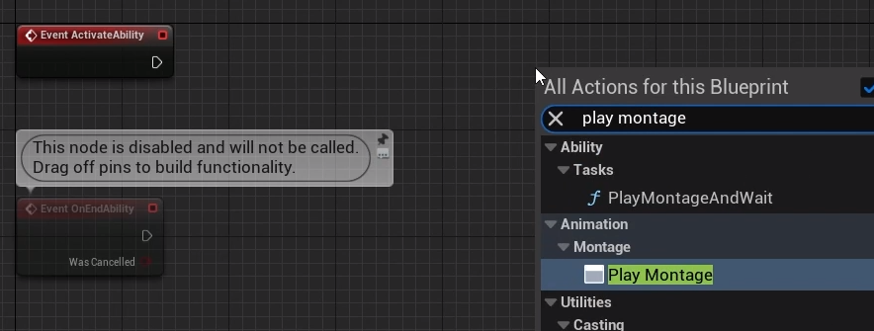

This is what is called a Latent Node, latent as in asynchronous or ‘will be executed and then, depending on what happens later, there are a number of output pins that can be executed’

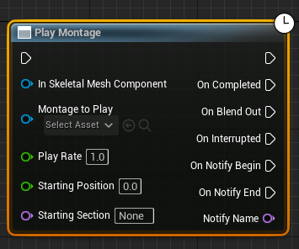

There’s an input pin to the left, and regular output execution pin to the top right

The top right output is executed immediate after we reach the node, allowing other functions and logic to be called or performed.

But then there are also a number of circumstances that can trigger the other outputs to flow like ‘On Completed’ when the montage is completed, or ‘On Blend out’ when the montage starts to blend out and is not interrupted. Depending on blend settings this could be before On Completed (usually is). On Interrupted is self explanatory, on Notify Begin is executed when using a play montage notify, or a play montage notify window inside the montage, as we can put notifies in the montage. On Notify end for when a notify window ends – there are a number of things that can cause any of these to trigger.

This is just a Blueprint latent node (aka an Async Task). GAS has more specialised forms of these latent nodes which are more ingrained in the ability system itself – for example Play Montage And Wait under Ability-Tasks

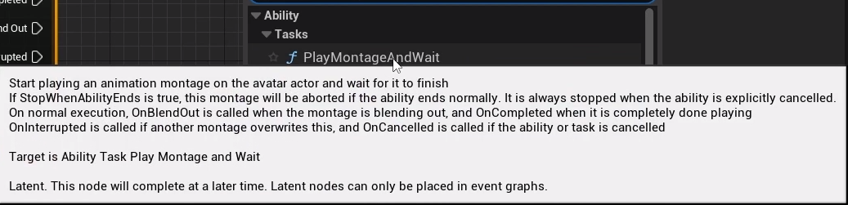

This is an ability task and if we click this it looks a lot like the other one but has more options

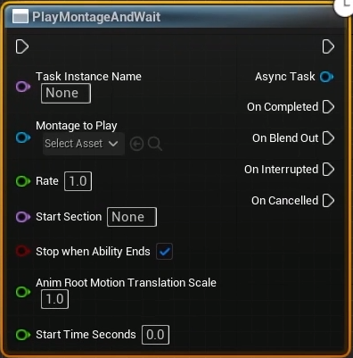

There are a number of entries in the GameplayAbility.h related to montages; a given ability knows which montage is currently playing if we’re using the GAS version PlayMontageAndWait

This node will do what it says – play a montage and then wait for one of the outputs to happen

We can hardcode in a montage to play:

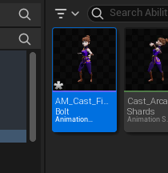

The new Montage is set to the default slot but we need to be using that slot, so we should double check in the AnimBP ABP_Aura:

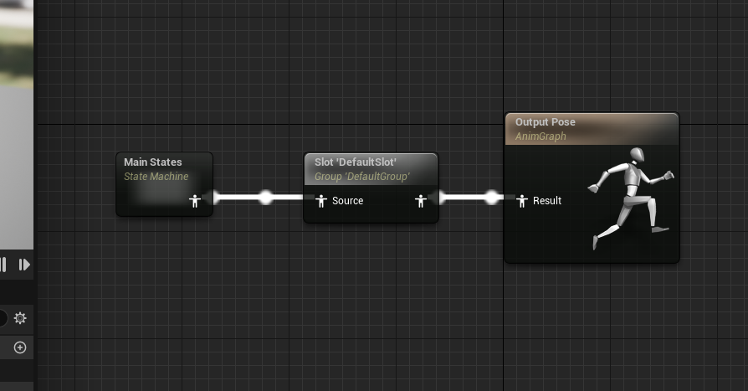

Yes, default slot is there, so if we play the montage we will actually see it played

Now we have created the Anim montage we can add it to the node in the GA:

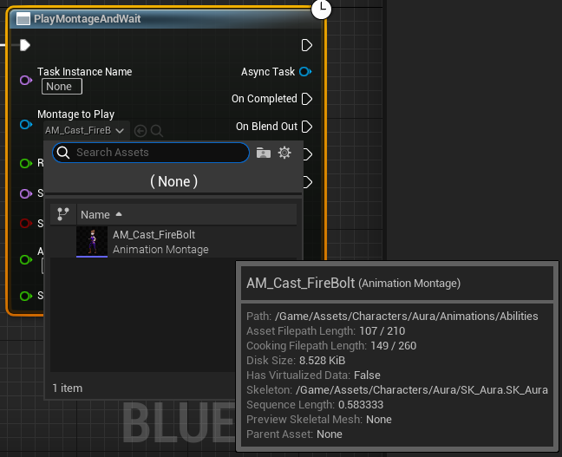

We can confirm that the topmost execution wire is executed right away by printing a string

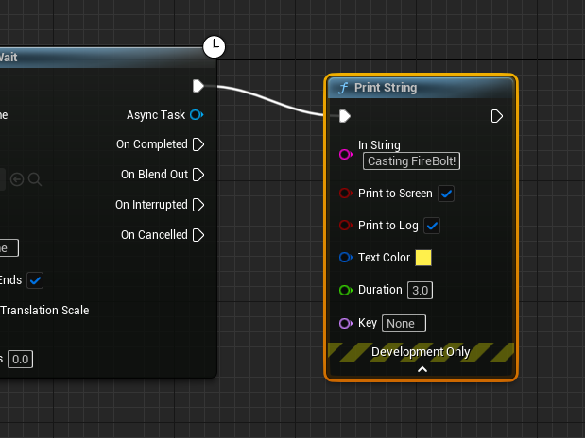

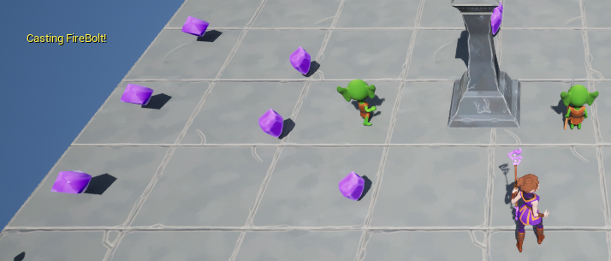

The firebolt spawns immediately rather than in time with the animation

On the montage: Blend options we’ll update from 0.25 to 0 (no blending) and reduce the blendout to maybe 0.1

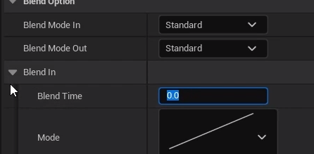

The print message is also played immediately on pressing because it’s from the top right output

But we can also do things later!

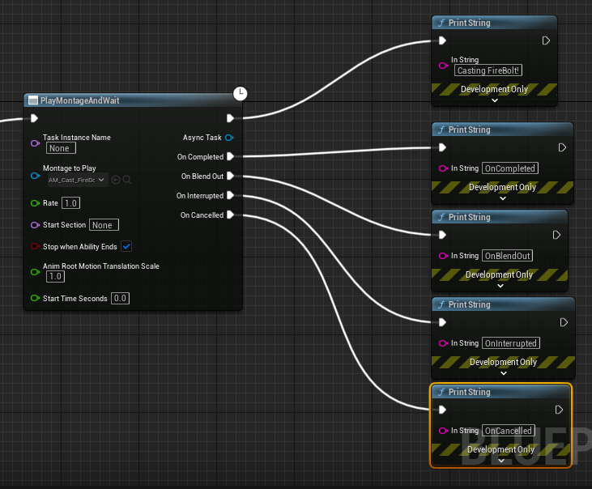

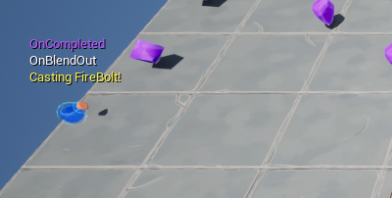

There’s a time gap between the cast, the blend out and the completed, allowing us to do things later in time without using timers – we can base activity on the length of a montage

How does this BP node work, become Async?

This appears to be a class based on UAbilityTask

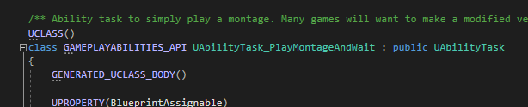

“/** Ability task to simply play a montage. Many games will want to make a modified version of this task that looks for game-specific events */”

The task has a number of delegates  
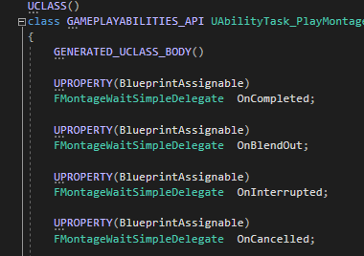

Those are the names of the output execution pins

When you create a Ability Task and add NP assignable delegates to it those become output execution pins

Next we have this:

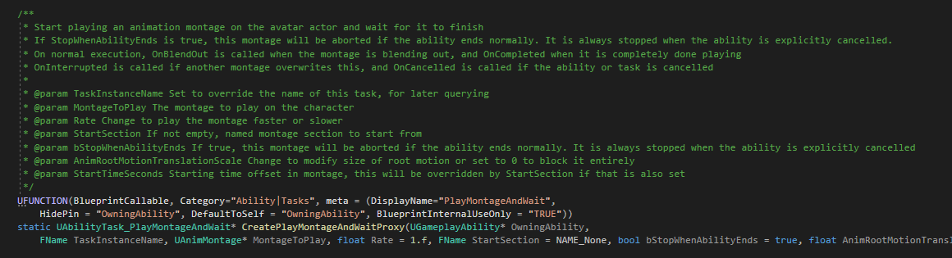

Static function 

“UFUNCTION(BlueprintCallable, Category="Ability|Tasks", meta = (DisplayName="PlayMontageAndWait",

HidePin = "OwningAbility", DefaultToSelf = "OwningAbility", BlueprintInternalUseOnly = "TRUE"))

static UAbilityTask_PlayMontageAndWait* CreatePlayMontageAndWaitProxy(UGameplayAbility* OwningAbility,

FName TaskInstanceName, UAnimMontage* MontageToPlay, float Rate = 1.f, FName StartSection = NAME_None, bool bStopWhenAbilityEnds = true, float AnimRootMotionTranslationScale = 1.f, float StartTimeSeconds = 0.f);

This returns a pointer of type “UAbilityTask_PlayMontageAndWait”

It’s BP callable, has a category and a meta with displayname (so the Blueprint will not show the “UAbilityTask_” at the start.

It also has “HidePin = "OwningAbility"”, so the BP will not show an input pin for that parameter, which is also set to ‘Self’ by default (in C++, it would be ‘this’)

In the CPP file:

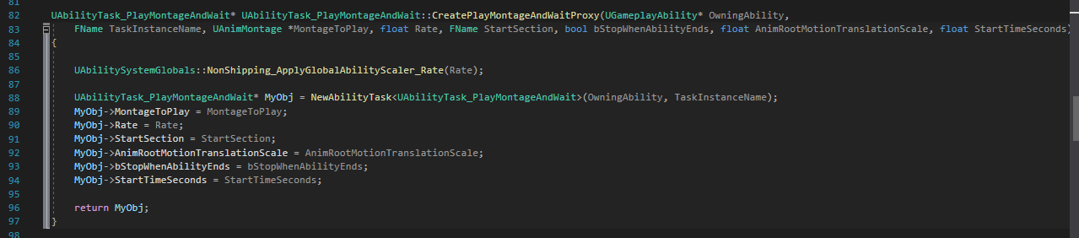

This function creates a New Ability Task with an internal function of the same name.specifying this particular task, and then setting a number of parameters on that new task and returning it

So these ability tasks have a static function that creates an instance of themselves and returns it after setting a number of input parameters that can be exposed to the BP

It’s made to be created in Blueprint, although the function could be called in C++, and we know it has a number of delegates

As soon as we create this ability task, ability tasks have an activate function and when they are activated, whatever happens inside this function is what happens

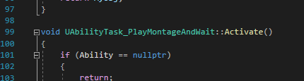

PlayMontageAndWait will obviously play a montage

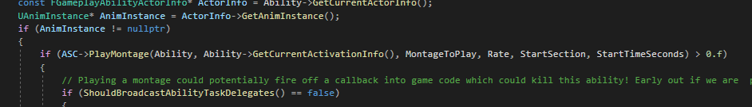

It calls play montage on an ASC

How does it well which one? Ability tasks have an owning ability system component

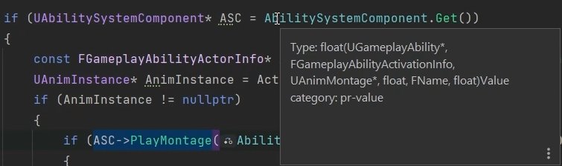

It’s also binding some function callback to some delegates (the output pins from the header file)

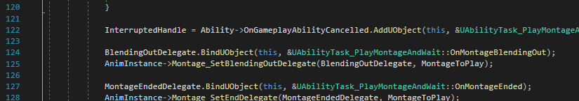

It’s binding it’s own OnMontageBlendingOut function here

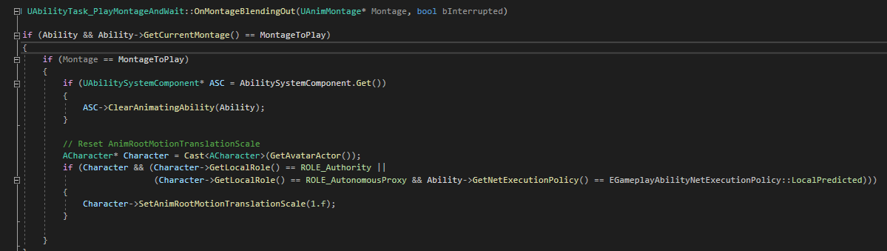

The function calls ClearAnimatingAbility on the ASC, gets the character from the AvatarActor, checks authority, sets anim root motion scale etc etc

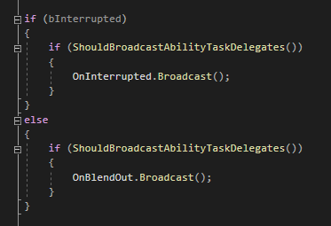

It checks if it’s being interrupted and if so broadcasts that, same for onBlendOut

An Ability Task is a C++ class that has a static function – a factory of sorts – that constructs an instance of itself, that is BP Callable, and has a number of delegates that are broadcast based on things that are happening. It also has an activate function in which the delegates have some callbacks that are bound to them. These delegates can be broadcast based on whatever logic we implement here (this example happens to play a montage and then broadcast delegates when the montage is finished or other related cases)

The ability task gets the anim instance from the ActorInfo associated with the AbilityTask’s ability and owning ASC



So now we have an understanding of how this works.

But what if we want to wait for something that is NOT one of the cases specified here?

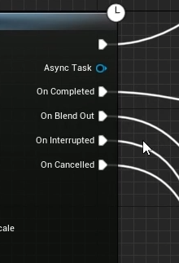

What if we want to wait until a certain point in the montage before we do the next thing like Spawn the projectile?

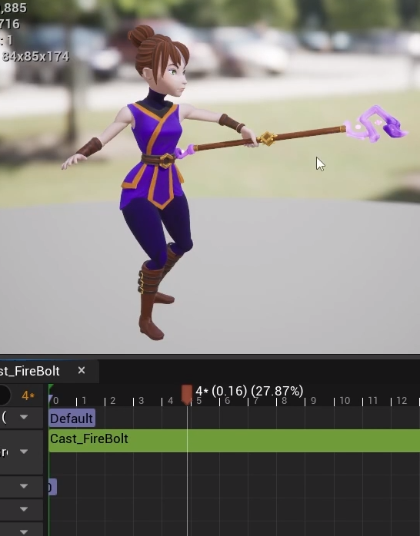

# Sending Gameplay Effects

We’ve seen some cool stuff in PlayMontageAndWait as an ability task, but how it fits together isn’t clear yet because we’ve not yet created one

Well, we just use a notify in the anim montage to indicate at what point the effect actor spawns

We’ll be making a custom anim notify that sends a gameplay event, not just a SpawnActor in a Blueprint – gameplay events can be sent along with data to a given actor and a gameplay ability can listen for events – there’s an ability task for that

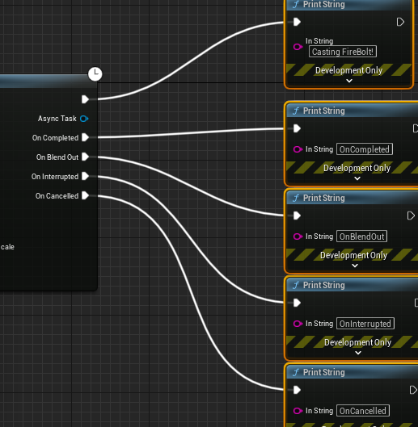

Deleting the test print strings and instead immediately after PlayMontage and replacing it with the ability task Wait Gameplay Event

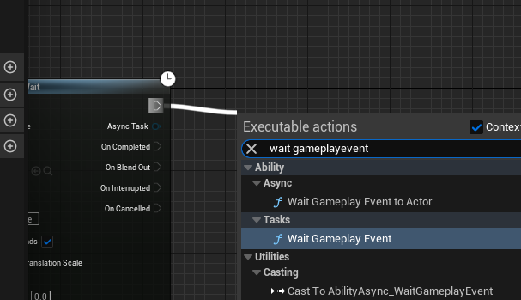

This will wait for an Event to be sent to the actor that has the ASC that is activating this ability

We specify what event we are waiting for – event is identified by a gameplay tag. So we can create a gameplay tag designed to identify specific events eg Launching a Fireball

Since the tag is not one we need to access from C++ we can just add it to the project in Editor (non-Native)

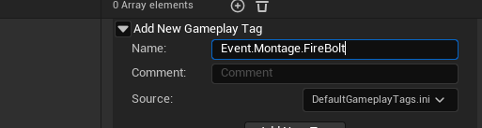

It’s an Event tag, it relates to Montages and it’s for the FireBolt ability

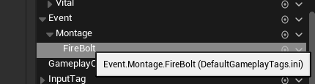

If we want to spawn the Firebolt from the montage we’ll send an event that has this gameplay tag

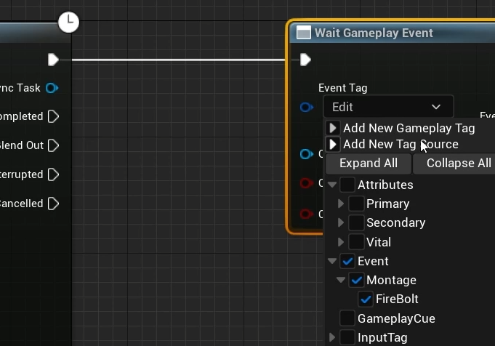

So we just need to send that event in a custom anim notify

New BP class of type AnimNotify

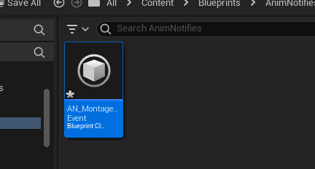

To be used for any montages that want to send a gameplay event

Function to override:

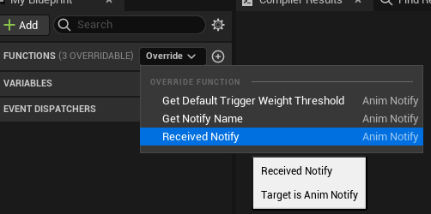

This function will be called when we reach the notify

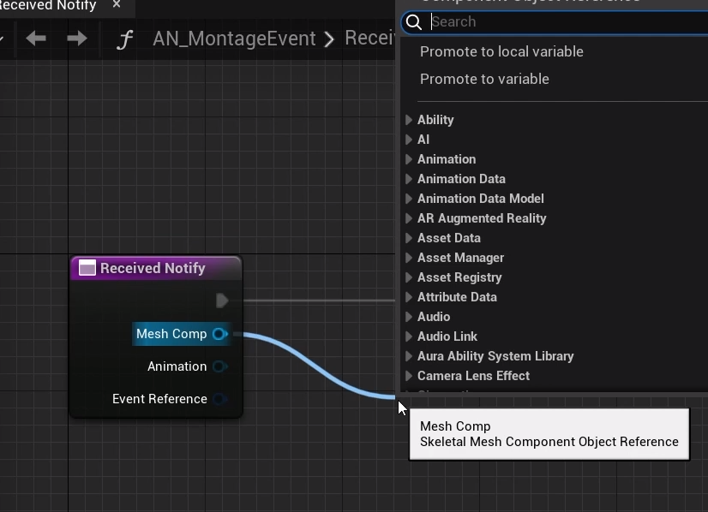

We have the mesh component associated with the animation montage that is executing this notify, so we can call get owner on it

We can also get from the menu Send Gameplay Event to Actor from the Ability system static library

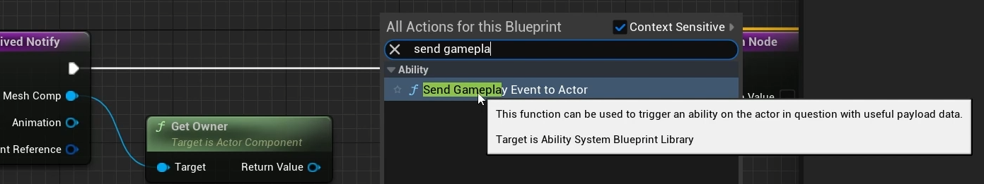

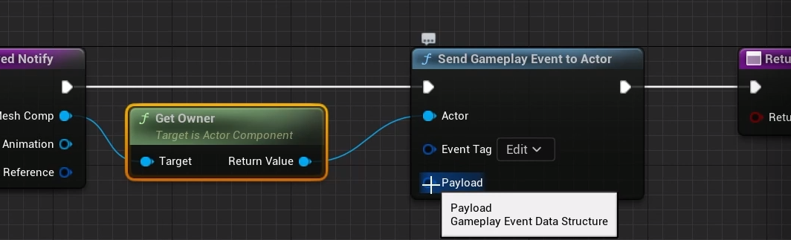

As we are sending the tag to the actor, we can also send additional data in this payload struct…

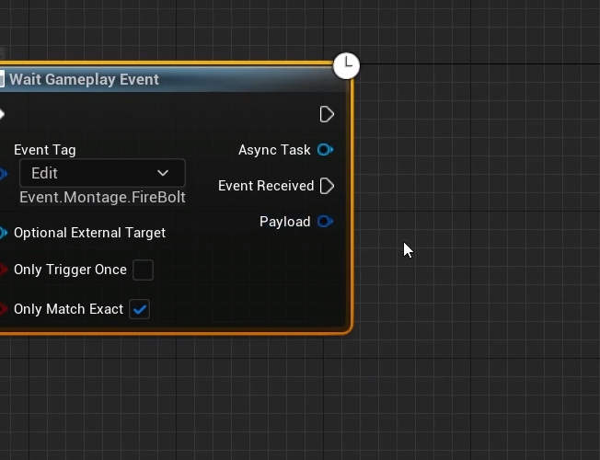

And it matches this payload output in GA_FireBolt, along with the Event Received execution wire

As soon as the owning actor receives the event, Event received will be executed and will receive the payload

Promoting the Event Tag to an instance editable variable

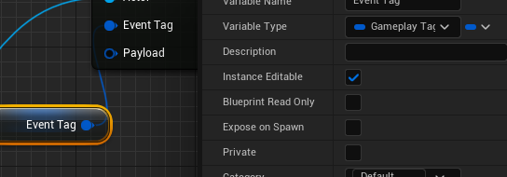

Payload:

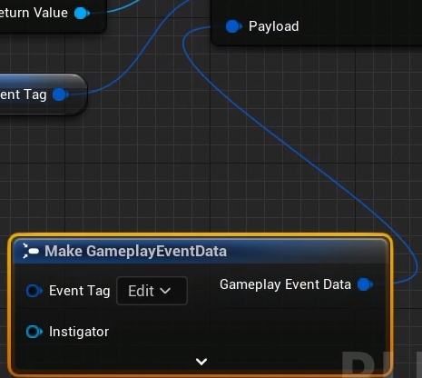

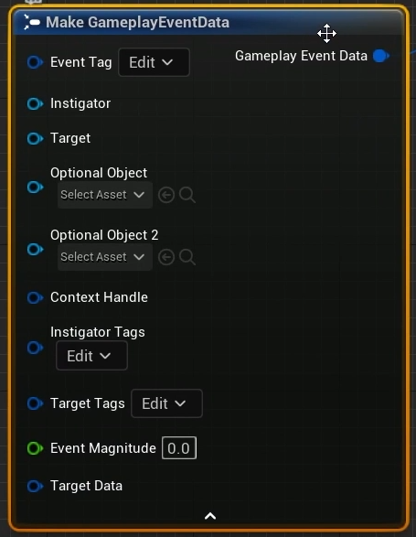

Contains a ton of data, and ‘Target Data’ is itself another struct!

For now we’ll just send the tag

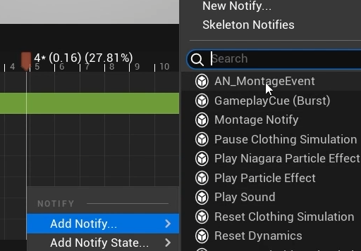

The event tag variable was exposed, so we can specify that here

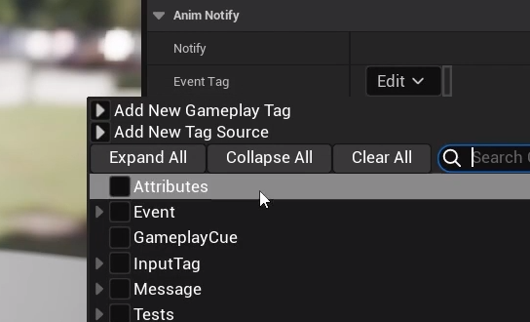

No, the montage reaches the notify and triggers it, the Notify then sends the tag using Send gameplay event to Actor. The wait gameplay event was waiting for the event with the tag, receives it and then executes the Event Received output node

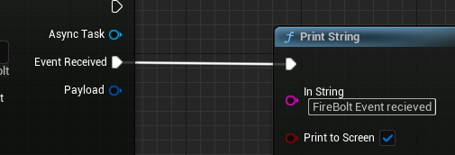

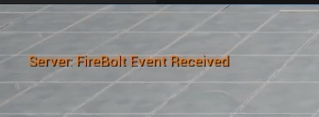

Of course the FireBolt is still spawning immediately, because it’s being done in the Activate Ability C++ - we’ll want to update this. The main thing is we’re receiving the event thanks to the notify which called the AS blueprint library function send gameplayeventtoactor – we can even call this in C++

Next: make sure we spawn the projectile only when we receive the event – it doesn’t look right when spawned immediately

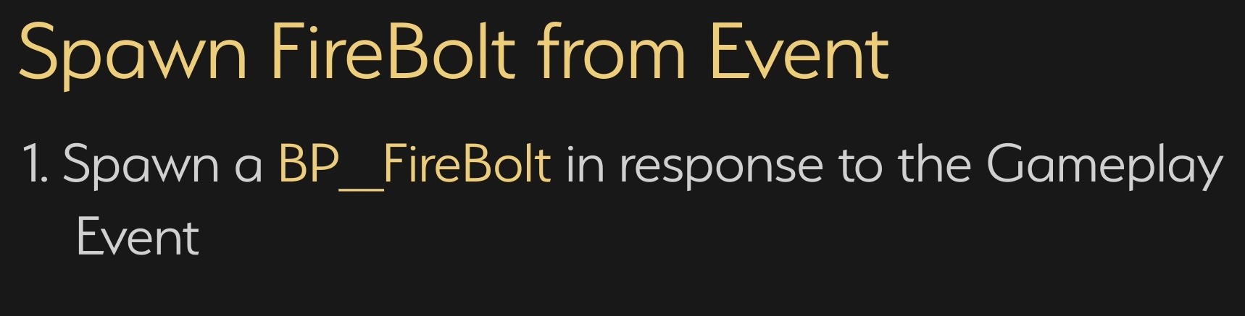

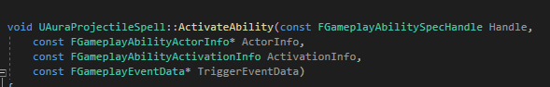

Automatically called when the ability is activated and spawns the projectile. However we need to spawn the projectile a little later, so this is not the place to do it.

Instead make a BP Callable function so this can be done in response to a gameplay event and migrate most of the code into this function

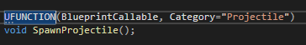

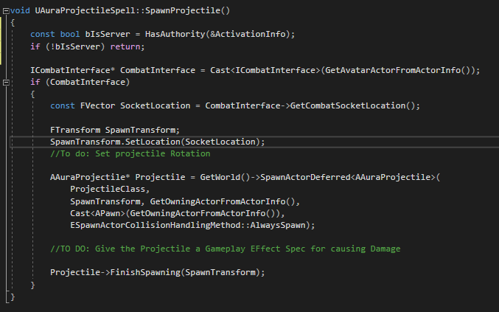

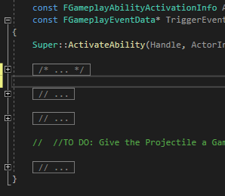

However we now do not have the ActivationInfo



No problem:

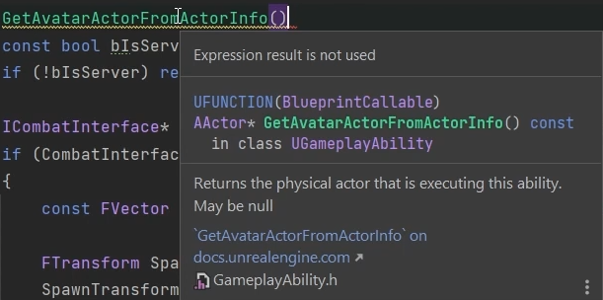

This will return an actor that is the avatar, if we have one. If so we can call HasAuthority and use that instead

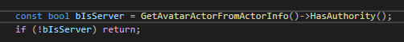

So this new function, SpawnProjectile, will check if we are on the server and if so spawn the projectile in response to an event. It’s BP Callable, so we only need to call it from the BP

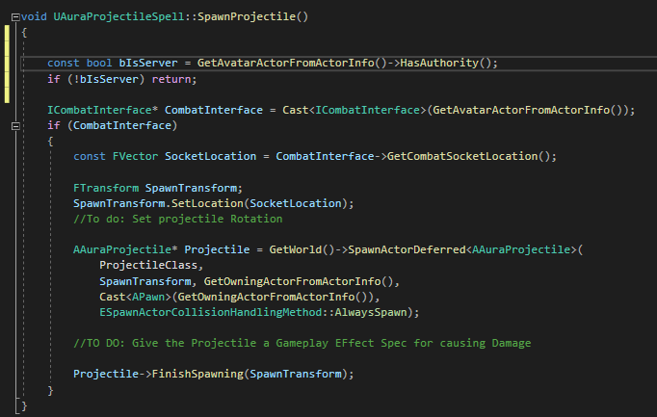

The function is BP callable and GA_Firebolt is a child of Aura Projectil Spell so:

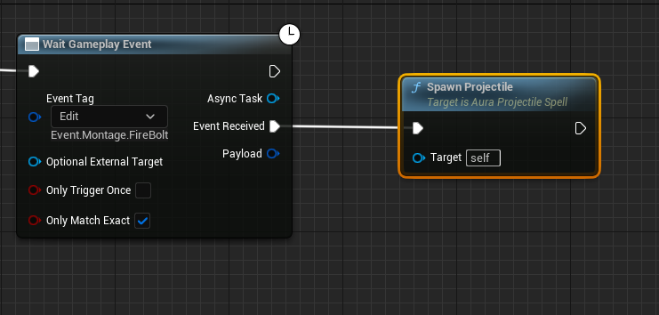

The FireBolt now spawn as soon as the anim reaches the notify, not instantly!

This means that we can now trigger a gameplay effect in response to any event we choose in theory!

Now that we have spawned the projectile we can end the ability here, and then we can use it again

It’s not a long animation so currently it can be spammed, so we’ll need to add a short cooldown later, but there are some other issues to address

ToDo:

Projectile Rotation

Orient the character in the direction of the target

For this we need to know the location in space of the target

# Custom Ability Tasks

In order to orient the character and get the correct vector for the fireball the best info is the data from the cursor hit result.

We can create an ability task that will get this data for us

In GA_FireBolt we could get the Cursor hit result as soon as the ability is activated (or the location associated with it), and use that. Test in single, then adapt to make it work in multiplayer as well

New AbilityTask class!

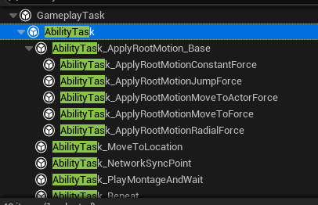

It’s based on GameplayTask and note that the engine has a number of AbilityTasks already built-in

Note the use of the name ‘Target Data’ – in GAS Target Data has a specific meaning, more later!

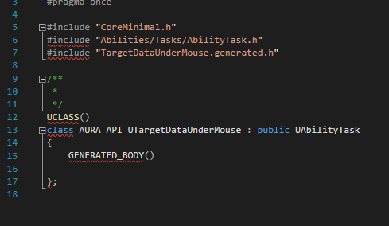

We’ve already seen PlayMontageAndWait and saw that I had a static function that created an instance of the class and returned it. We’ll follow that pattern here

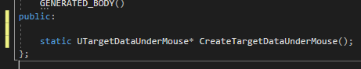

The function will receive the owning GameplayAbility, which is typical for AbilityTasks, they take in a UGameplayAbility pointer

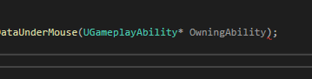

When we call this function from within a GameplayAbility this parameter should be passed in by default and it should be the self pointer (in BP it’s self, in C++ it’s this)

UFunction macro:



The function is Blueprint Callable in a category

The meta means that the node when called in BP uses this name

The Owning Ability pin is hidden, and defaults to self

It’s an internal function, basically a factory

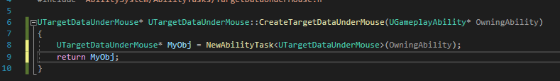

So we create a new AbilityTask of type TargetDataUnderMouse, save it to a pointer named MyObj and return that

We could also set any number of variables on it, could take in any number of input params to be passed in on the BP etc

Let’s see what it looks like!

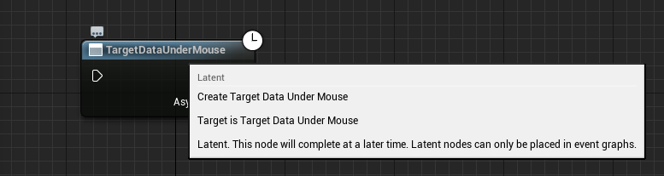

Currently all this does is return the instance of the TargetDataUnderMouse object. Not much we can do with that…we can call GetObjectName and print to screen, that’s about it

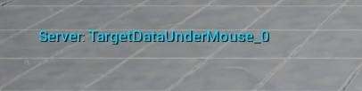

We can hook it up, but we need it to return some data

Not the clock icon in the corner, this is an asynchronous output node, so it can have multiple output pins

These output pins recall are created by broadcasting delegates, so any output execution pin needs to exist as a delegate variable on this class



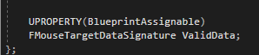

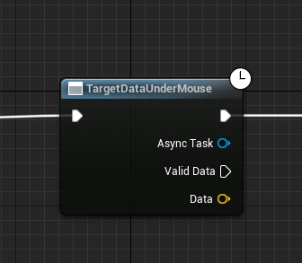

Now there’s an async output and a data pin, which is an FVector by reference! :D

Right now ValidData isn’t going to be executed, because the only way to execute is to broadcast the delegate, and when the delegate is broadcast is when we get the output from Data

To trigger this broadcast, we will need to Override the AbilityTasks’s Activate function!

Then, as soon as the BP node is executed, Activate will be called

Activate is originally defined in GameplayTask (not even AbilityTask!)

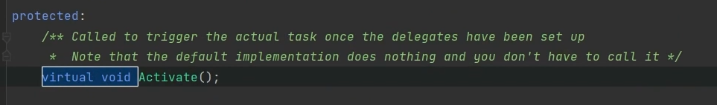

As we can see in the definition

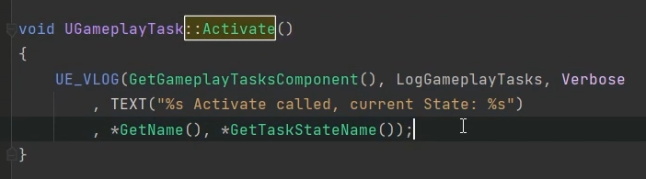

The parent of this function just makes a log note; no point calling Super, doesn’t do much

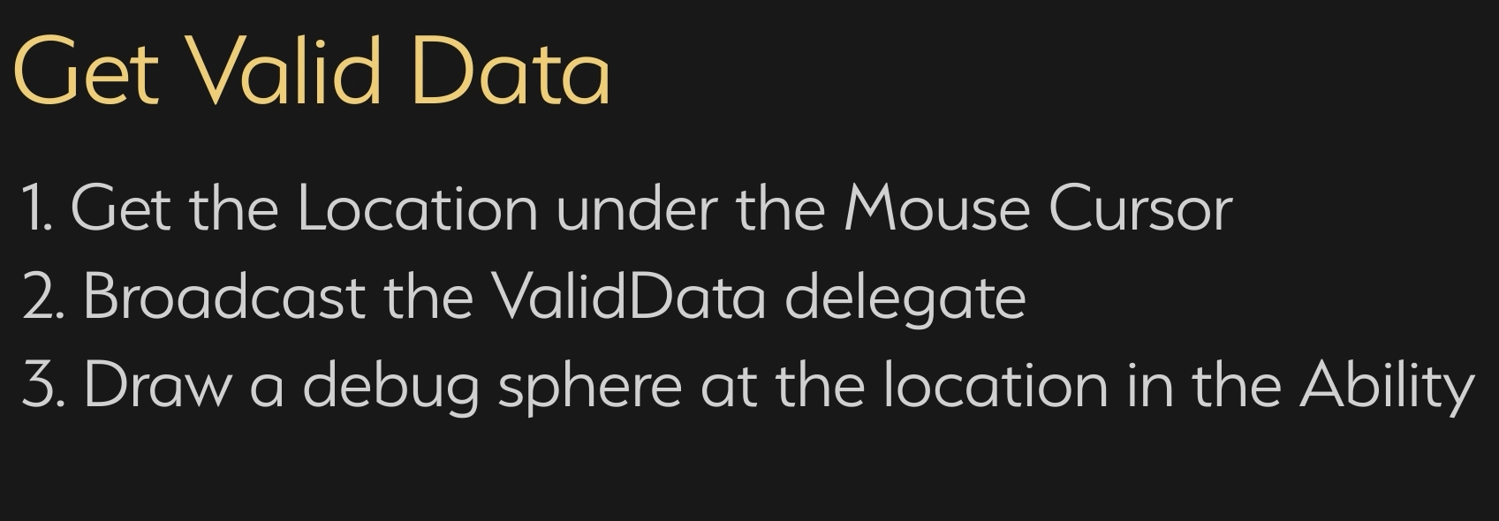

AbilityTasks have an internal variable Ability, and from this we can GetCurrentActorInfo

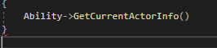

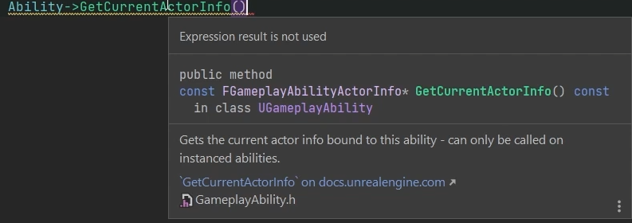This returns FGameplayAbilityActorInfo

Which has a number of variables on it including the player controllers

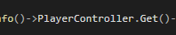

Player controller is a TWeakObj pointer so we need to .Get() on it



Now we can create a local FHit and pass it in

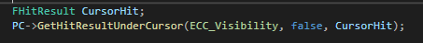

Finally, we broadcast the data (the location of the hit result) with the delegate

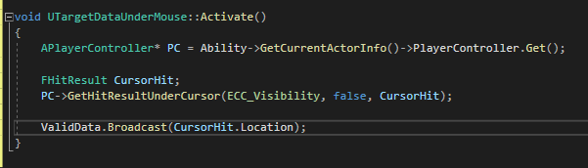

So, as soon as we activate the ability, we broadcast the delegate and the ValidData execution pin will be executed (but it doesn’t HAVE to be, it’s an async task, so if a game mechanic calls for a delay we can do this)

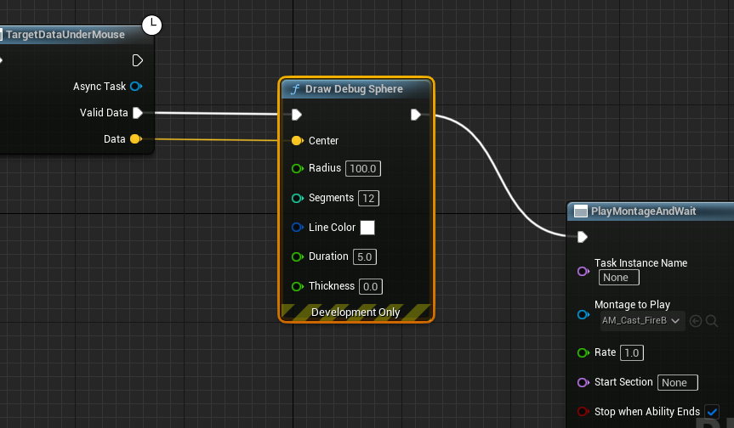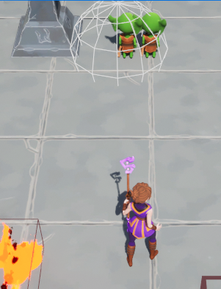

**In multiplayer however:**

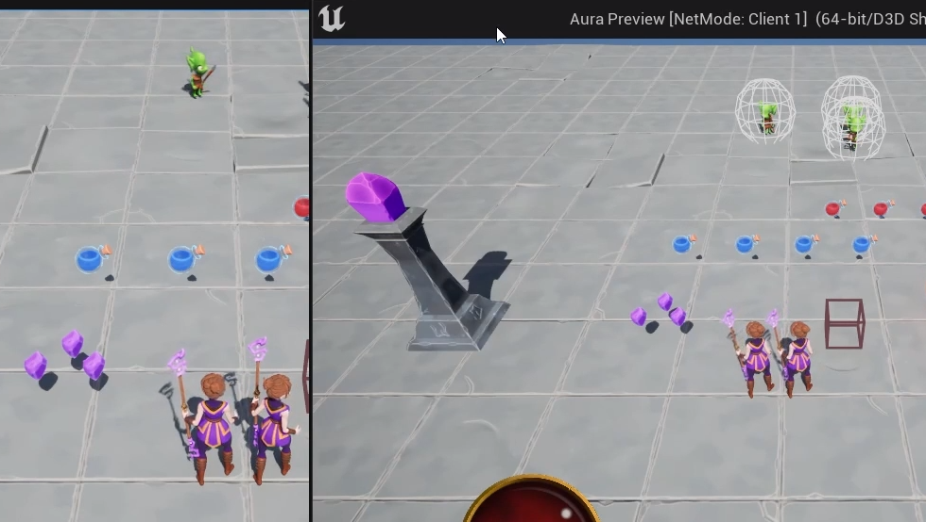

The debugsphere draws OK in client, but not on the server, so so the same would be true for the firebolt target!

Actually, it is being set…

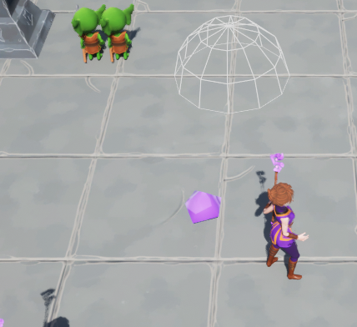

At the world origin, indicating the the data is empty!

That’s because the click is only local; so the server doesn’t know about it

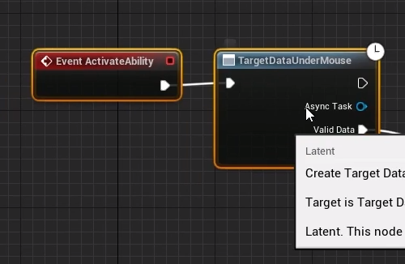

Activate Ability is being activated locally, and because Abilities are replicated, it’s also being called on the server. But on the server the delegate is broadcast even though we don’t know where the mouse cursor is!

Next step: get data (mouse cursor location) from client up to the server in a reliable way

# Target Data

Epsilon represents the time taken for the AbilityTask Activate function to replicate to the server

Delta represents the time taken for a remote procedure call to send Data to the server

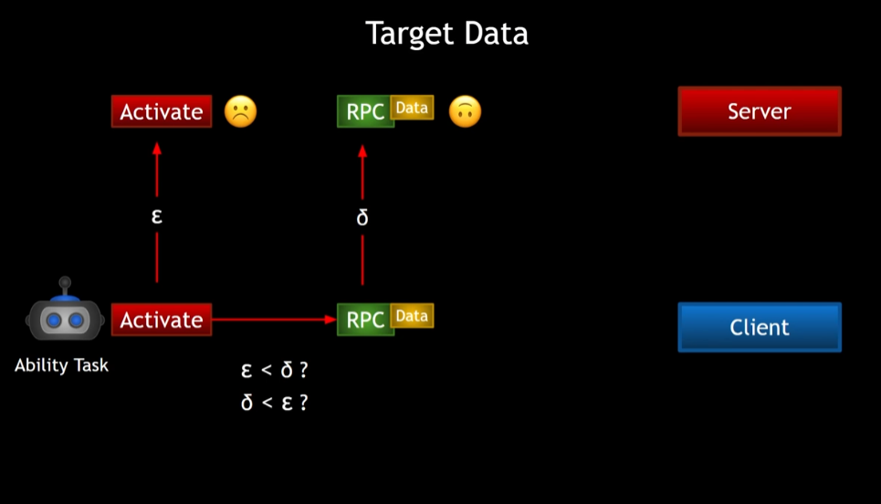

If Epsilon is less than delta, the Activate call is replicated before the RPC can be called and the server will not have any valid data

If delta is lower, the server will get the data, after which activate is called

We cannot determine this or guarantee the order in which they will execute

For this reason, GAS has a built-in target data system

There are multiple types of target data, all based on a struct FGameplayAbilityTargetData

There are ways to send data to the server, like function ServerSetReplicatedTargetData()

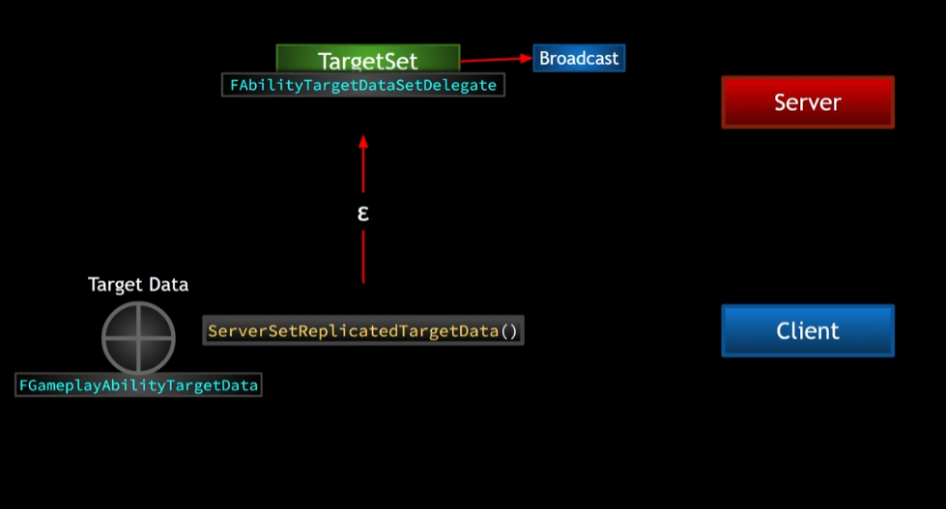

Server receives the data and then broadcasts delegate TargetSet

Any bound callbacks on the server can then be called in response and receive that target data

Server maintains a map called AbilityTargetDataMap, maps AbilitySpecs(and other stuff like prediction keys) to TargetData

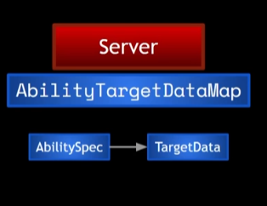

So, it’s possible that once Activate is called we can use ServerSetReplicatedTargetData to send up the Data

On the server we can bind Activate to the TargetSetDelegate

So if e < d then it’s fine because once d arrives the delegate broadcasts

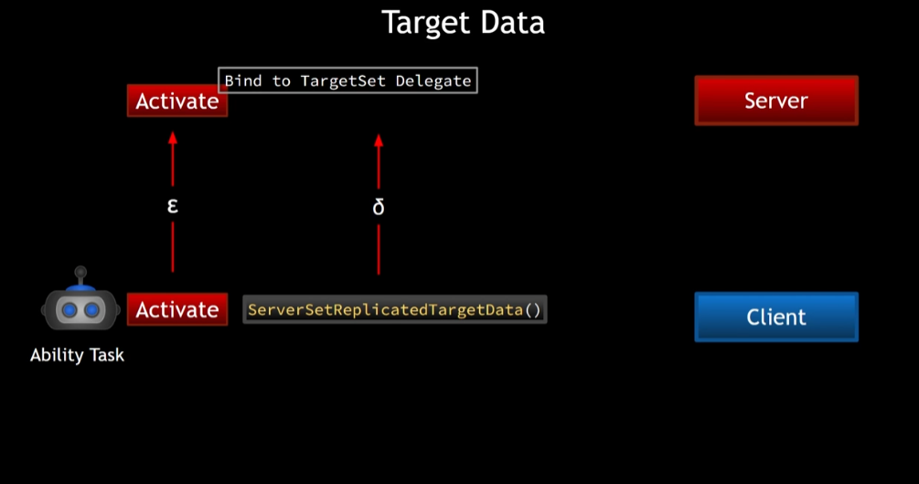

However, if d < e, the Activate is called after the broadcast, so we missed it!

That’s OK, in that case we can call CallReplicatedTargetDataDelegateIfSet()

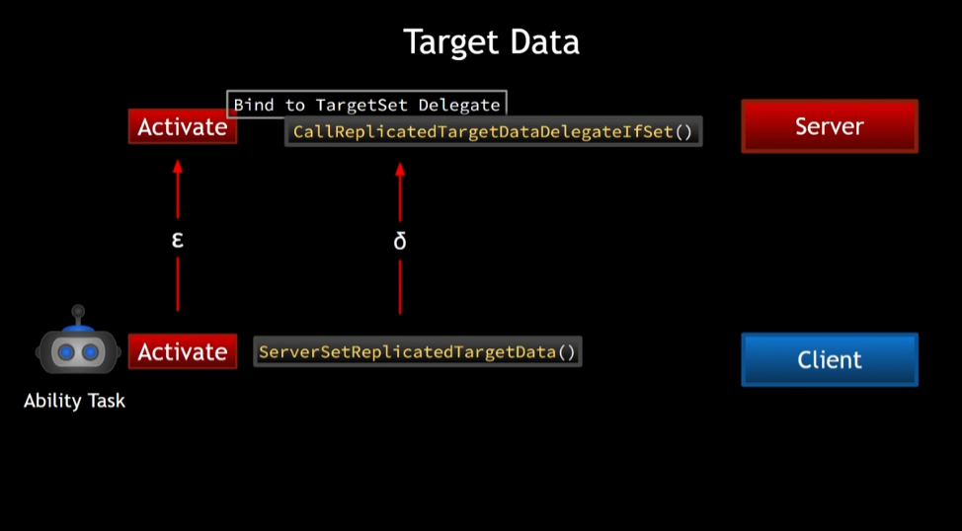

# Send Mouse Cursor Data

So, just getting the mouse cursor data and broadcasting is not going to work as if it’s not a locally controlled player the cursor hit will not have valid data. So we need a function that will send the data to the server if we are locally controlled

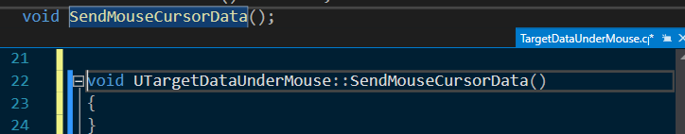

So, first we will check if we are locally controlled, and we’ll do that first thing in Activate

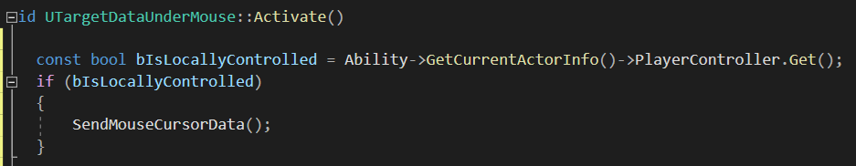

And if so call SendMouseCursorData()

If not then we’re on server so

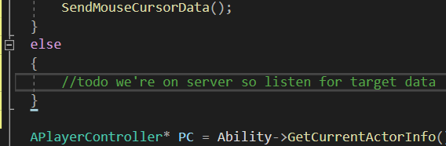

Send mouse target data needs to actually create some target data to send

What **is** target data anyway?

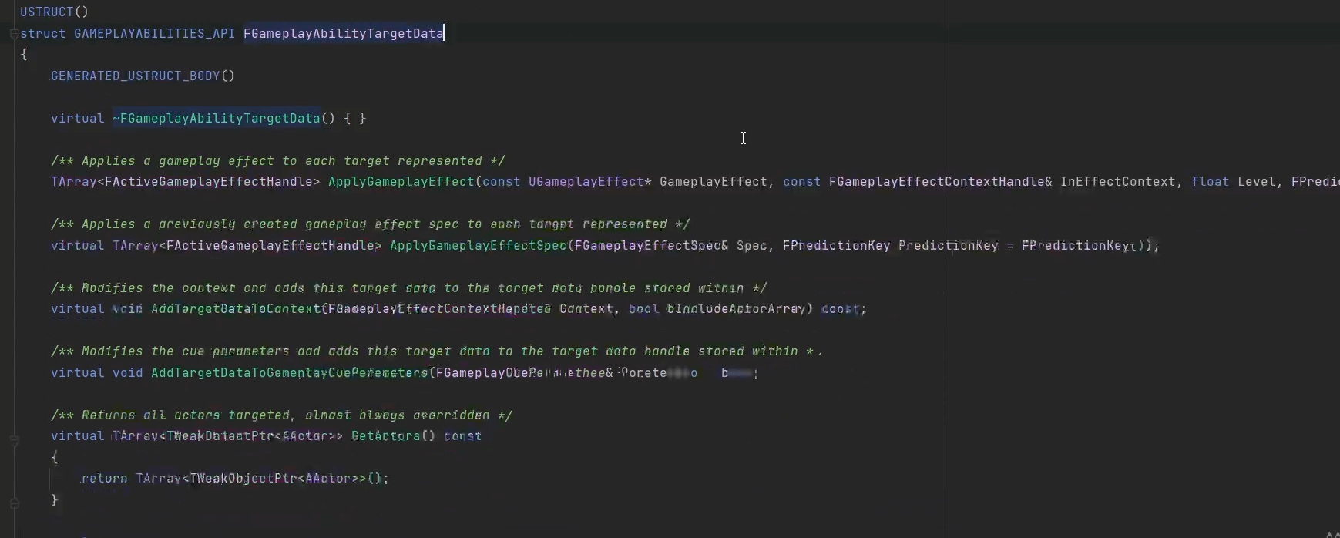

It has a few functions, most are virtual and can be overridden

There are classes derived from GameplayAbilityTargetData

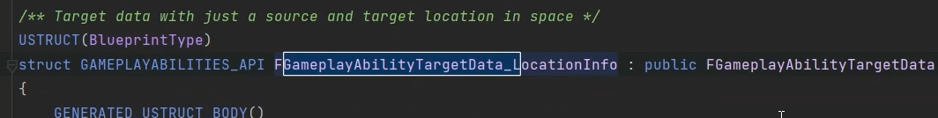

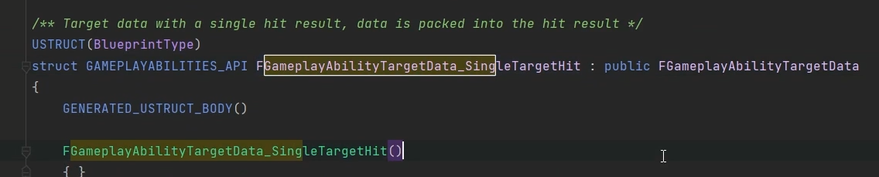

This one, single target hit looks interesting, if we sent this to the server the server can get the location from the hit result

So let’s create a new object of this “FGameplayAbilityTargetData_SingleTargetHit”type

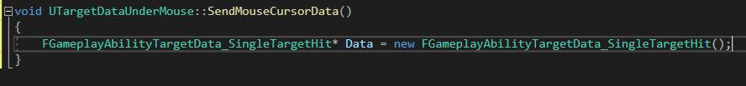

Now we have a pointer Data, of type FGameplayAbiityTargetData_SingleTargetHit

So if we’re locally controlled, SendMouseCursorData will create a new object of this type

Now we can just get this data and set its hit result because Data is a FGameplayAbiityTargetData_SingleTargetHit, which has a HitResult internally

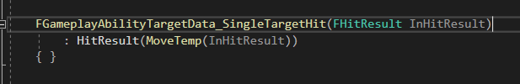

So we can set the HitResult equal to the hit result under the cursor

We’ll just move all the code for that CursorHit variable into the function:

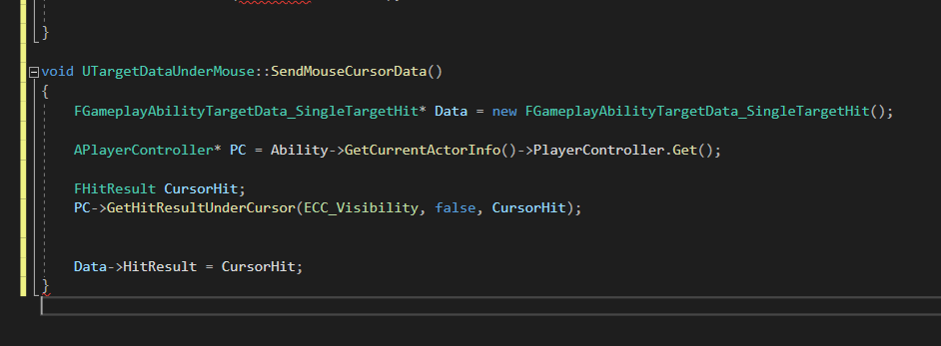

Note that the Broadcast line has NOT been moved; we don’t want to broadcast yet

Tidied up and reordered lines:

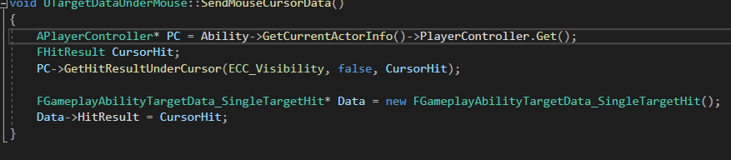

OK, we now have a TargetData object, but we need to send it up to the server now

That means we need to get the ability system component. AbiiltyTasks, recall, have an ASC variable

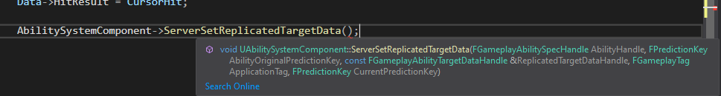

* First input: GameplayAbiiltySpecHandle
* Easily obtained with GetAbilitySpecHandle
* Next is a prediction key
* Anything that is predicted is associated with a prediction key
* 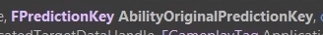
* ‘Original’ = when this ability was originally activated
* GetActivationPredictionKey()
* Next is 
* We have TargetData, but not a TargetDataHandle, so we need to create one
* Then package up the TargetData into the Handle
* 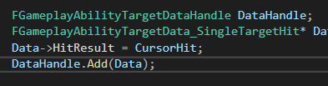
* Next: 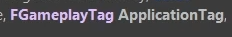
* This will be passed up whether we use it or not, and it’s a GameplayTag so lets just create it anyway
* 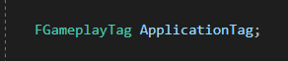 and 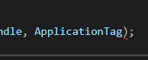 is one possible approach, but we’re not going to use the anyway so let’s just pass in 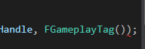
* After the Tag is ANOTHER prediction key, but this one is 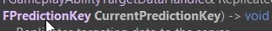
* The Original Prediction Key was associated with the activation of the ability
* We need one for RIGHT NOW
* Can create one with ASC
* 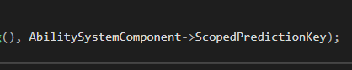

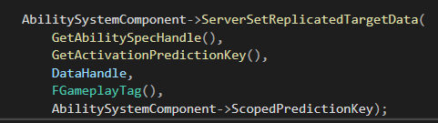

Now SendMouseCursorData is sending Data up to the server!

Of course we should still broadcast the valid data locally so we can see that cursor data locally on the client

But there’s a function we should check:

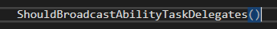

Why? Because there are some circumstances where we should not broadcast the ability task delegate

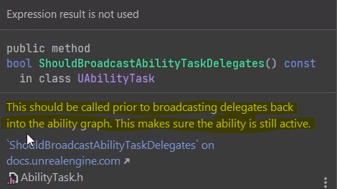

So if the ability is not still active this will prevent broadcasting

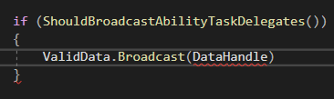

But…

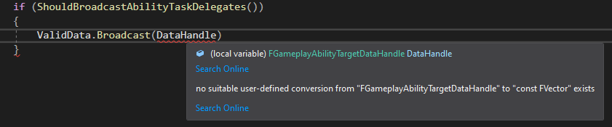

So we’ll go back and change the Delegate

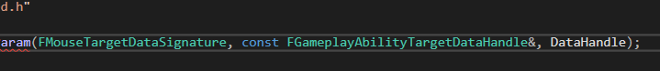

Type changed and renamed from Data to DataHandle

We’ll just get the FVector we want from the DataHandle

So, the data is now sent up to the server, and on the server we need to receive it

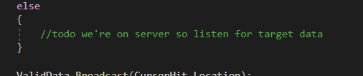

For now, let’s take a look at

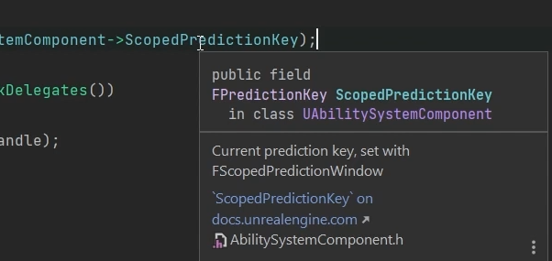

When is that updated?

We have to do that

We say we are creating a scope prediction window – a window during which everything we do locally is going to be predicted. It’s scoped, meaning it’s limited to the scope of where we are when we create the window

We’ll do it in the function before doing anything else



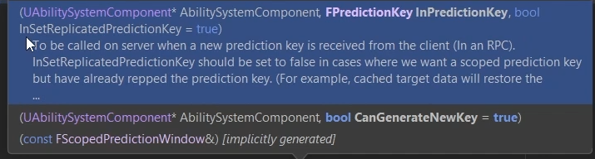



The Boolean is optional and true by default, which is fine

With the addition of this line, we’re saying that everything within this scope should be predicted

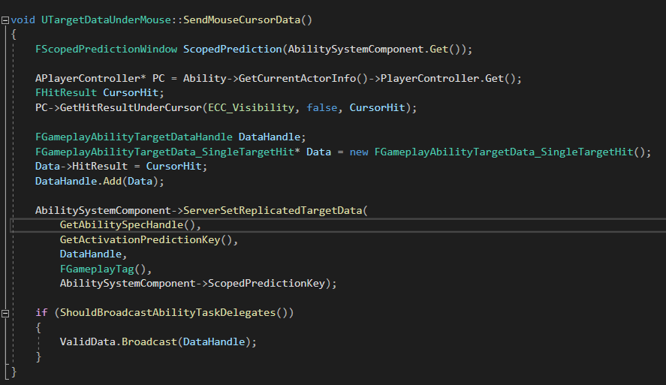

“Server, please allow us to do what we’re doing here locally”

Then the server will do it when it knows about it, and this is how we can do predicted things

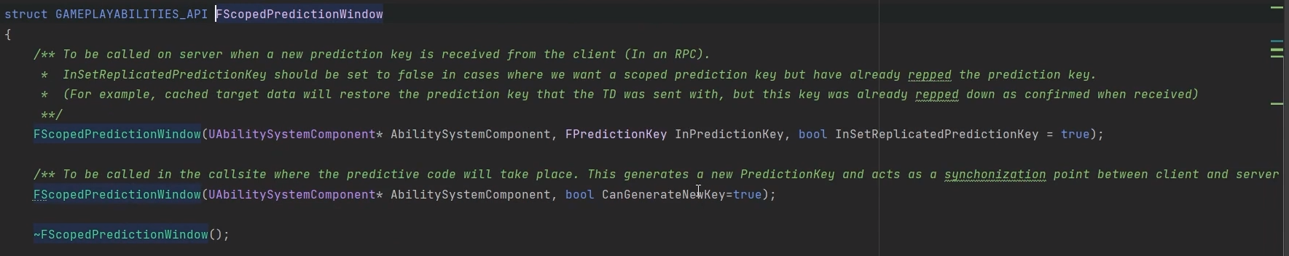

# Receiving Target Data

When TargetData reaches the server there’s a delegate broadcast, and we can get that delegate through the ASC

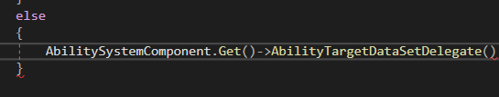

This returns the TargetDataSetDelegate, but it’s the delegate for a given Ability/Prediction key pair

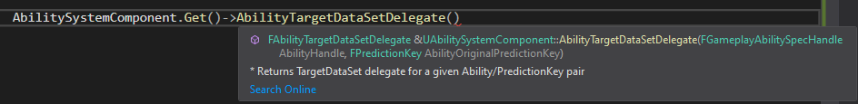

It needs to know the prediction key associated with the target data. In order to know that information the function we’re calling needs the spec handle for the ability associated with this specific task

So we need to get that spec handle

We can call GetAbilitySpecHandle for that

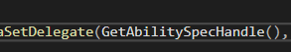

Next we need the key, and that’s the activation key

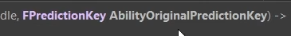

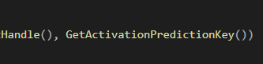

This function gives us the delegate and with that we can bind a function to it

Eg

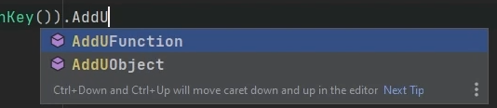

Or we could bind a lambda

Lets make a new function

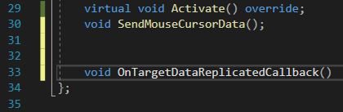

And it needs a very specific signature, because it’s going to be bound to this Delegate

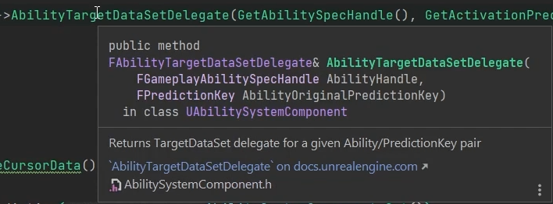

TargetDataSet is going to broadcast 2 things

The TargetDataHandle and the ActivationTag associated with it (even though the one we’re sending is empty)

The first will be a const “FGameplayAbilityTargetDataHandle” reference, the second an “FGameplayTag” passed by value

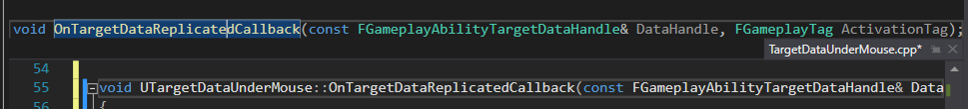

This is the function we’ll bind to the delegate

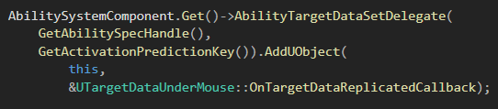

So, as soon as Activate is called on the server the server will bind it’s callback to this delegate

But what if this is called too late and the TargetData has already been sent and the delegate already broadcast?

In that case, we should call the callback anyway and there’s a way to check (or at least call the delegate if it’s already received target data) through the ASC

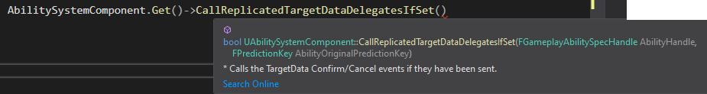

This requires the SpecHandle and the Prediction Key

This is a bit messy so making some locals

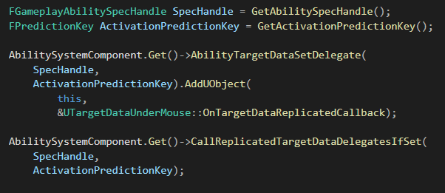

This will make sure we are calling this function

Now, this

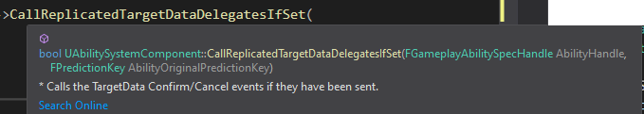

Returns a Boolean that is true or false depending on if the delegate is set and if we should still listen for it

If we look at the function definition in the parent we can see:

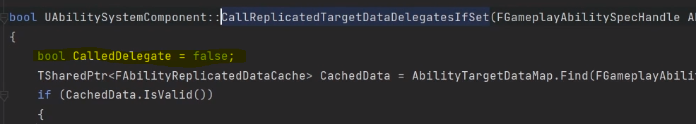

That there’s a local bool there to track this. It defaults to false but is set to true if the broadcast is made

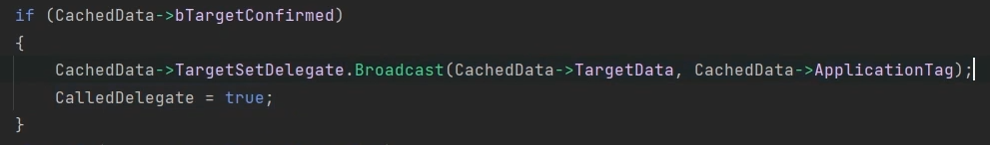

Because we’re broadcasting the delegate here if TargetData has already reached the server

So, we can store that in a const bool

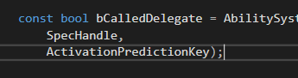

And we do this so we can tell the server to wait for player data to come through

If it’s already set and is broadcasting it, we don’t care any more. Otherwise if bCalledDelegate is false

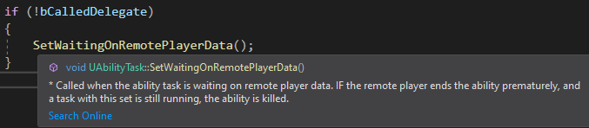

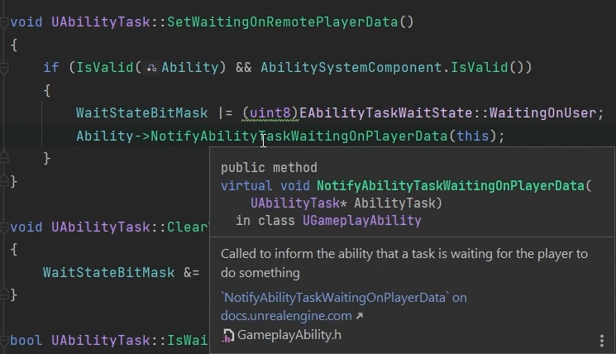

Tells the server ‘We’re waiting for player data’

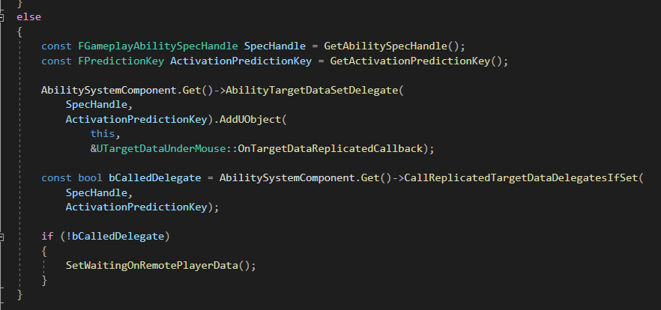

Final task is to decide how “OnTargetDataReplicatedCallback” behaves

We know that this function is called in response to receiving Replicated TargetData

**Actual** replication only happens server to client, but in GAS we see functions that use the term both ways – RPCs sending data is often referred to as Replicated Data, so this function is called on the server when ‘Replicated Data’ is received

In that case, we need to broadcast it so the AbilityTask in the GA has the ValidData execution pin executed. So we can broadcast that data but we also need the ASC to know that the data has been received

This is because when ReplciatedTargetData is received it is stored in a specific data structure

We can tell the ASC ‘Data received, no need to cache it’

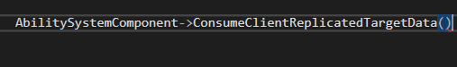

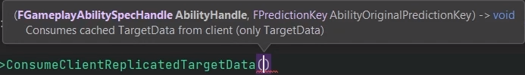



Definition of the Consume function:

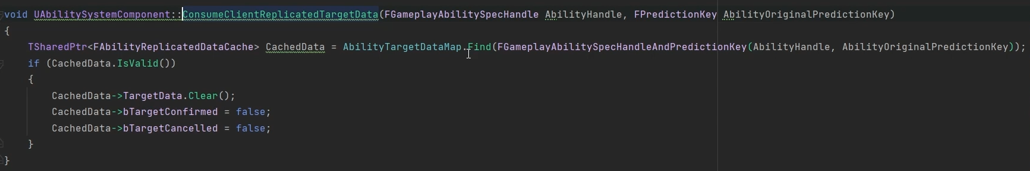

Through the AbilitySpec handle and activation key the ASC can find the ‘ReplicatedDataCache’ in the AbilityTargetDataMap

For each Handle and Key there’s an associated TargetData in that CachedData structure that will be cleared when we call that Consume function. It also has Confirmed and Cancelled bools so it knows whether or not the Data has been sent or received or whatever

So this function tells the struct ‘We’ve got the data, clear it from your cache’ for this specific Spec/Key

Now this is done we can broadcast the delegate (but we should still check

 )

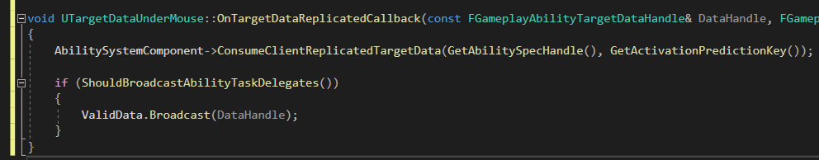

One last thing to do before this works, because in the editor:

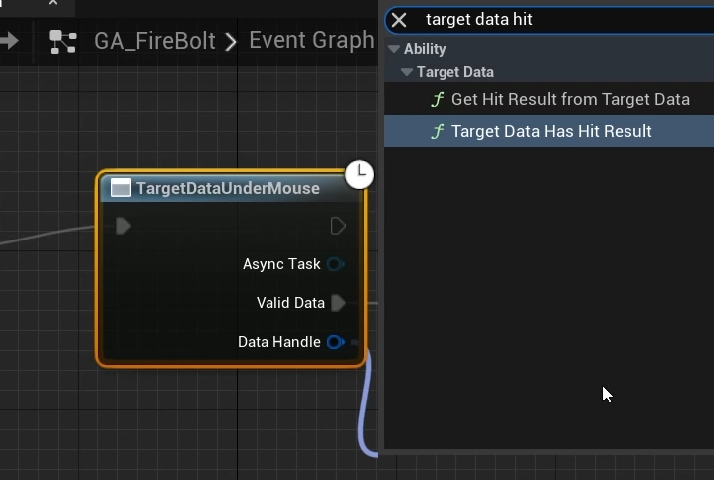 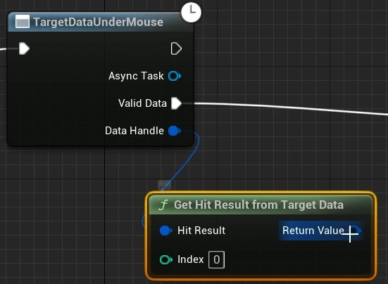

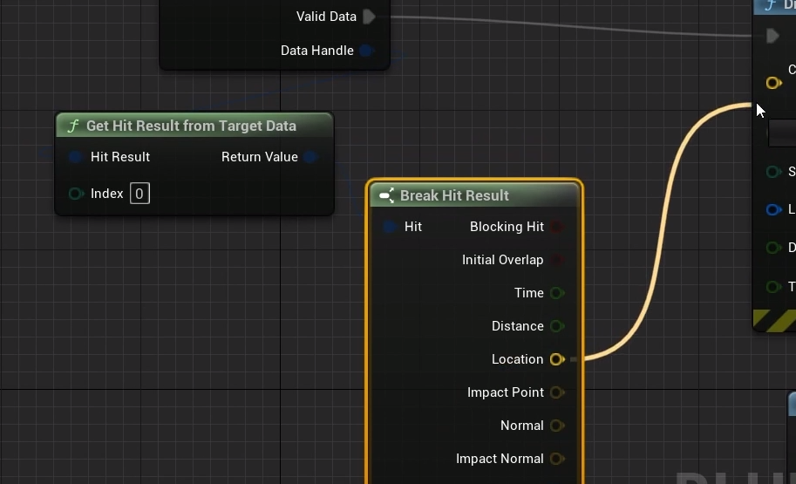 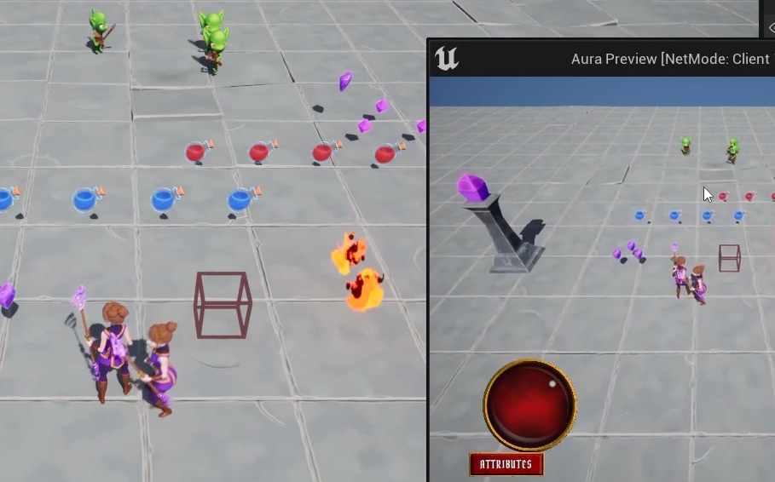

So far so good, but if we click on an enemy:

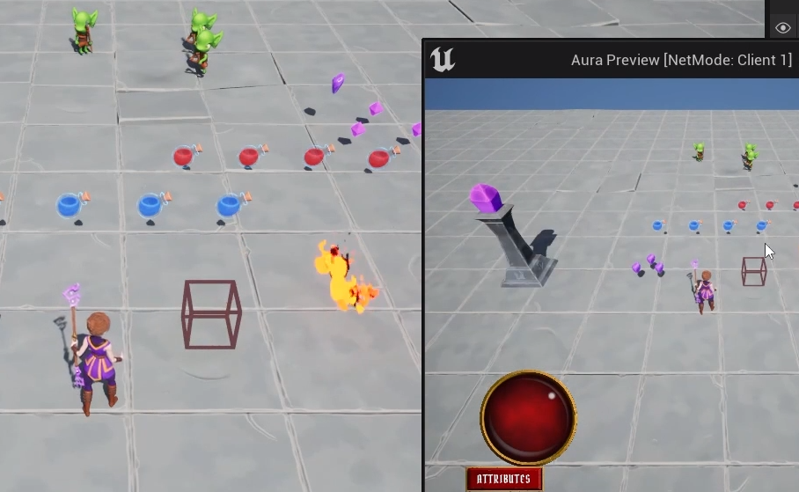 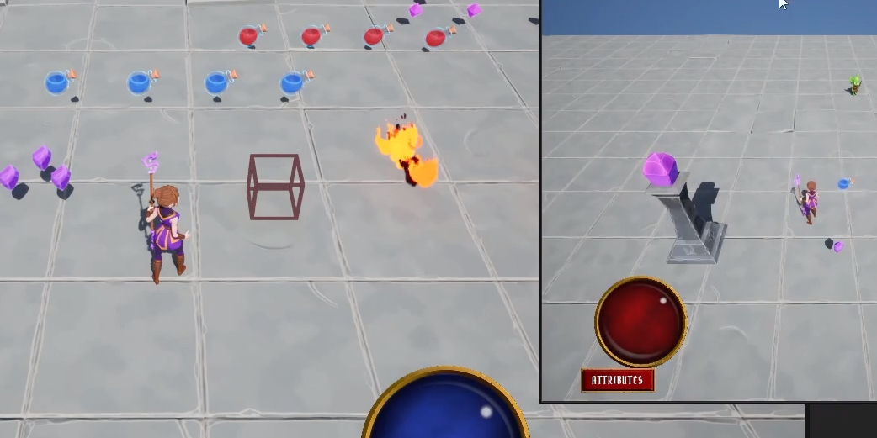

We’re now in a completely different instance!

The client has been disconnected from the server

Looking at the output log:



Because we need to go to the AuraAssetManager and add this line:

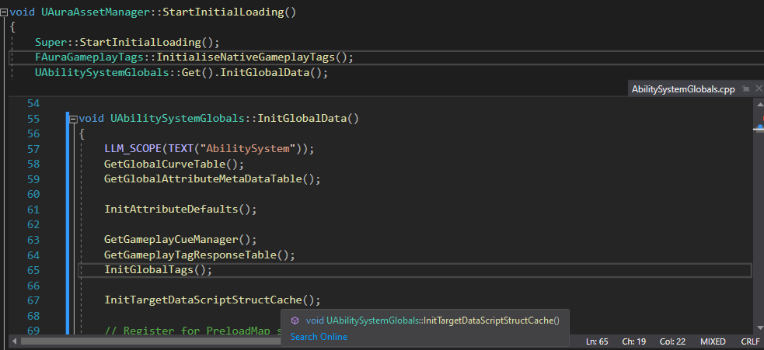

Initialising the global data, including target data, calling this InitTargetDataScriptStructCache

The struct is what the error was talking about, it couldn’t find this

Definition:

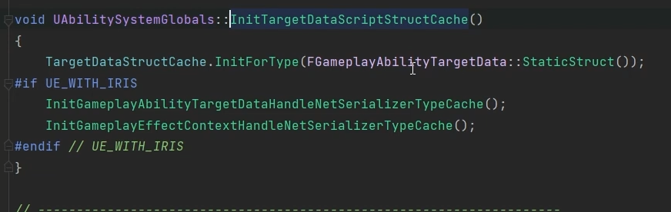

You see it’s calling StaticStruct on the AbilityTargetData

More about this at a later point

Testing:

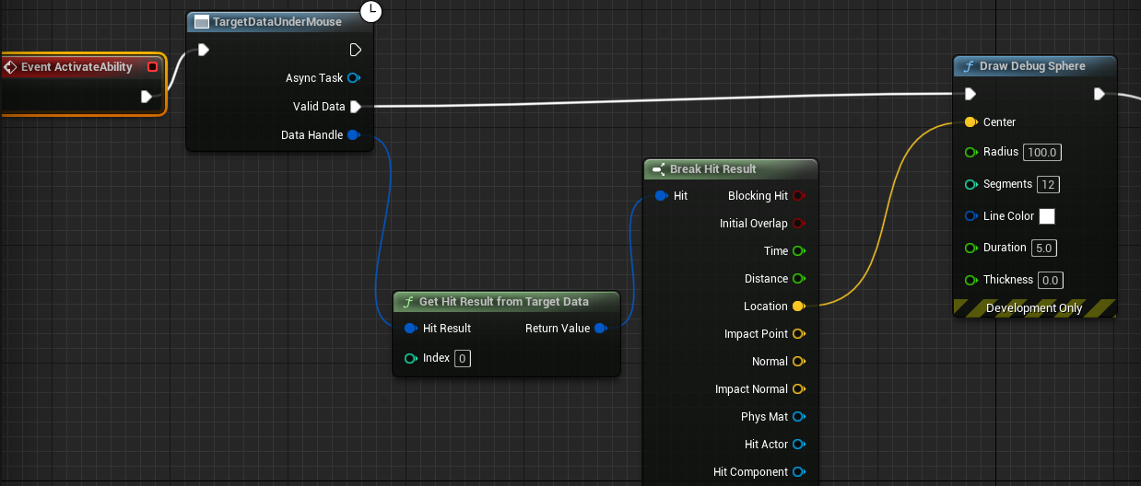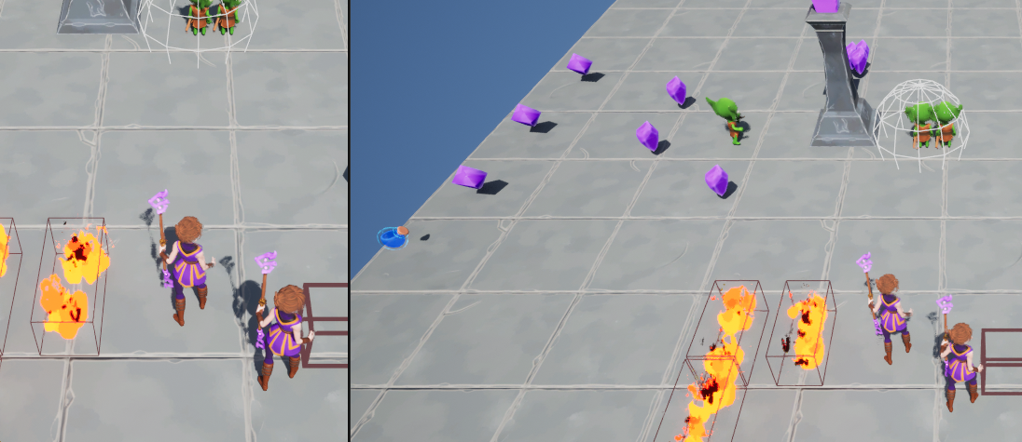

Server to client replication (of the debug sphere at least)

But we are successfully sending target data to the server and both sides know where it is

In 3+ multiplayer it’s not showing, but that’s OK, don’t really care, it doesn’t need to know

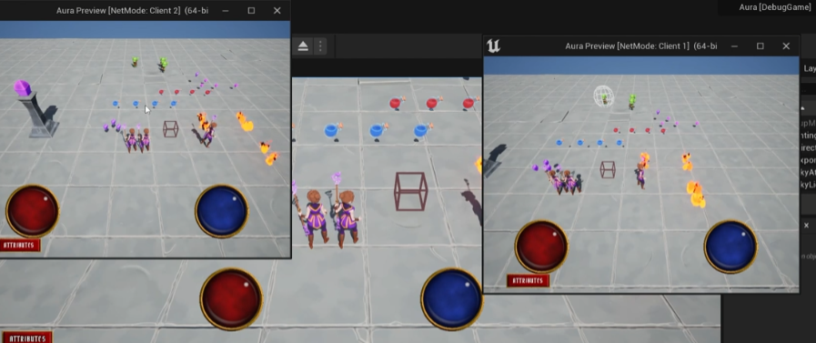

# Prediction in GAS

In Multiplayer games the server should have authority over any important changes in the gamestate. If clients have authority this means there are vulnerabilities that cheaters can exploit

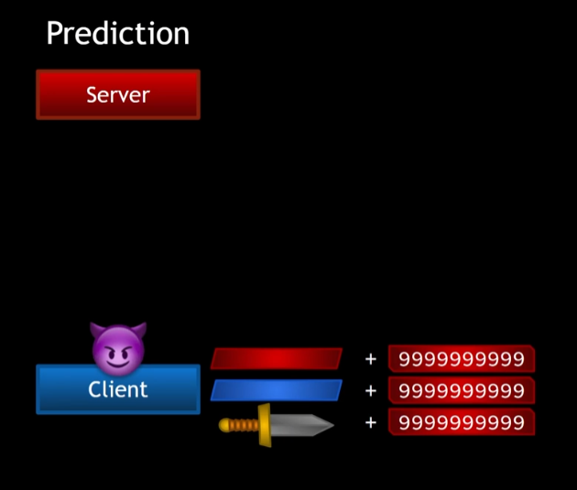

However, if clients must wait for confirmation that their requetss are valida noticeable delay would exist between performing an action and seeing the results

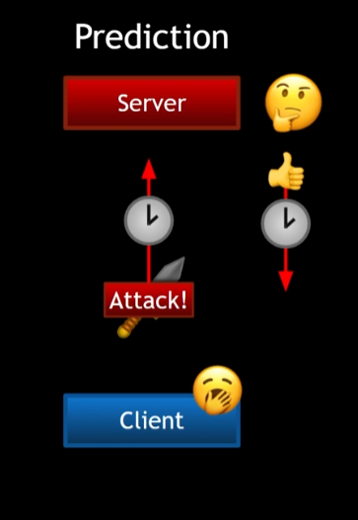

To mitigate this games make use of prediction, where the client makes a change (moving character, open door, shooting etc) and informs the server of the change. When the server gets the info to makes sure this is a valid change – the character has not walked through a wall, moved across the map instantly, opened a door it cannot reach or shot a weapon it does not own. If the change is invalid, the server undoes the changes

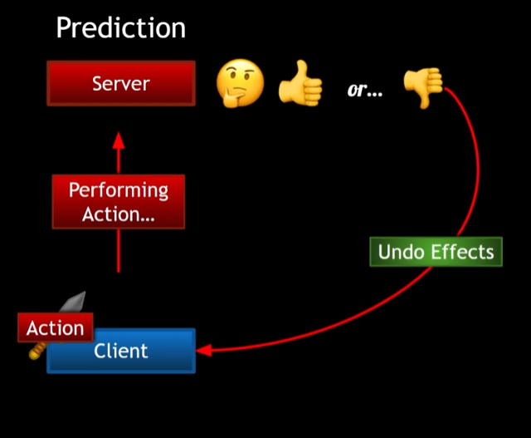

To have a playable experience fast-paced multiplayer games make use of prediction

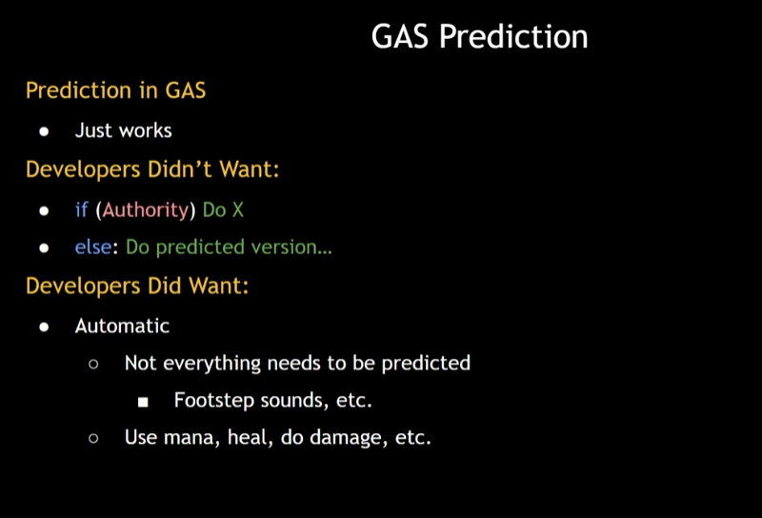 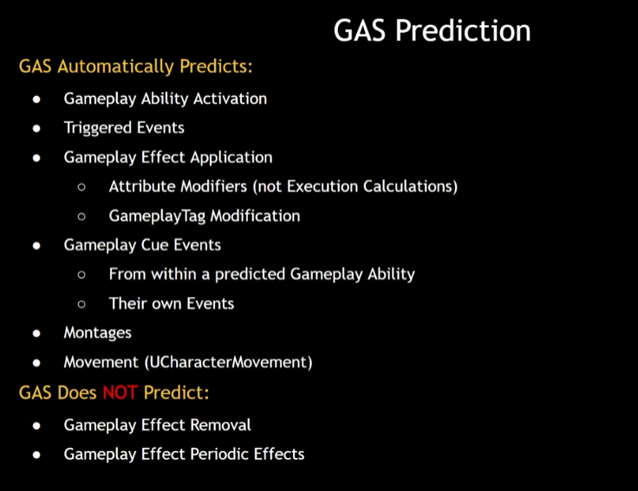

Predicitons in GAS are based on the prediction key – a unique ID stored in a central location on the client

When a client performs a predictive action it will send a key to the server and associate it’s clientside predicted actions and side effects with that key

Server will receive the key and either accept or reject it. It then associates any serverside created side effects with the key and respond to the client, informing if the key was accepted or rejected

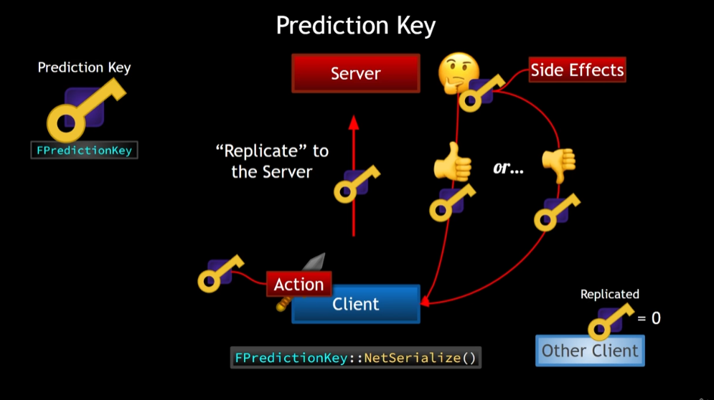

An FPredictionKey sent from client to server will always make it to the server

In the past we have said ‘replication only happens server to client’ but that referred to replicated variables (variables marked with ‘replicated’ or ‘replicatedusing’ in the UPROPERTY macro)

For these yes, only server to client. For sending a prediction key up to the server we use replication as a term of convenience

When a server replies to the client it will only send the key back to the client that sent it in the first place

This replication to the clients is done in FPredictionKey::NetSerialize(); all other clients receive an invalid key or with id0

A GameplayAbility in GAS is a ‘first class’ predicted action – whenever a client predictively activates an ability it explicitly tells the server, and the server explicitly responds

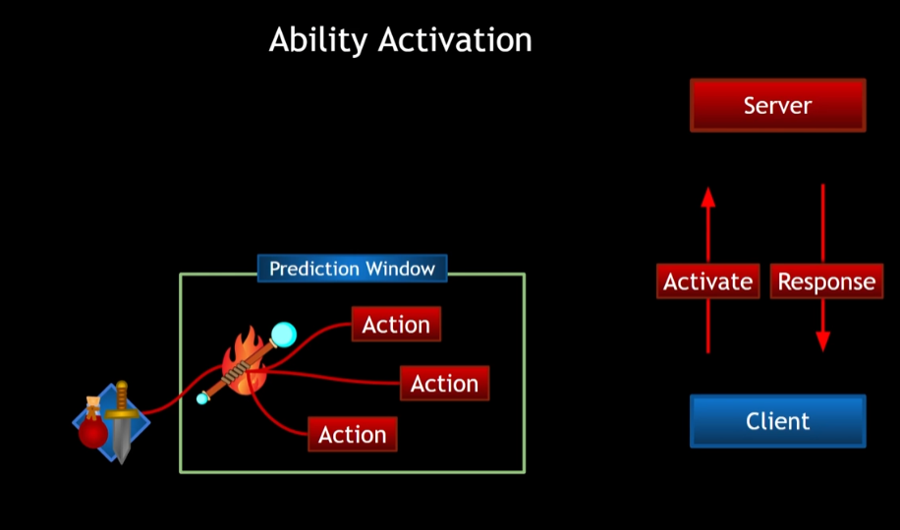

Whenever a client predictively activates an ability there now exists a window in which predictive actions can occur. This is a Prediction Window, and while it’s open the client can perform important actions that can change the game state like use up attribute resources, without asking the server for permission

The ASC has components for communicating the activation of abilities between client and server – for example TryActivateAbility

Once TryActivateAbility is called, a server RPC is also called – ServerTryActivateAbility

Then the client continues with ActivateAbility with the prediction key now in it’s ActivationInfo

All clientside activities now have that key associated with them

Once the server receives ServerTryActivateAbility the server decides if this activation is valid and then calls one of two client RPCs: ClientActivateAbilityFailed or ClientActivateAbilitySucceeded

Client responds to RPC

ASC has a member variable ReplicatedPredictionKey, and this is set to the generated Prediction key. Once it catches up to the client the client responds accordingly. The prediction key has it’s own Rep_Notif

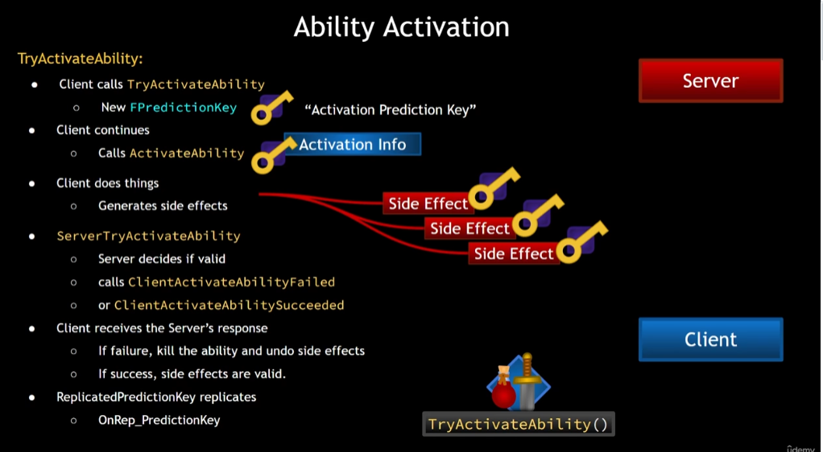

Side Effects:

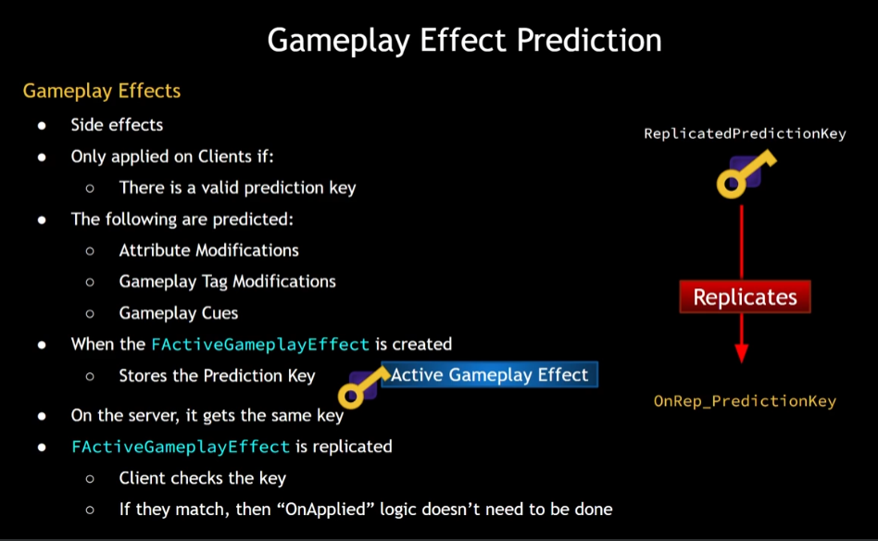

The local container will (temporarily) have 2 of the same gameplay effect, until the OnRep_PredictionKey arrives

# Orienting the Projectile

AuraProjectileSpell has a SpawnProjectile function, and it’s blueprint callable.

It should take in a location and space – the location under the mouse cursor

Since we are calling this function from the ability blueprint, we can pass the location in

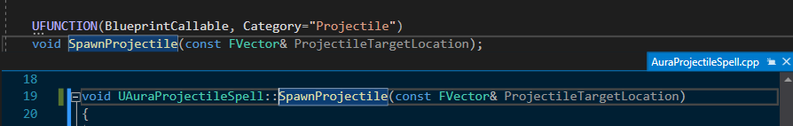

Added new argument

Now that we have this new location we can choose how to set the transform’s rotation

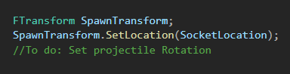

We have the socket location and know the target location as we are passing that in, so we can make an FRotator and set it equal to the target location – the socket location and from that get the rotator



This will be the rotation from the socket location to the projectile target location

The Goblins are small so the rotator will pitch downwards a little; we can make the FireBolt fly parallel to the ground by zeroing the pitch

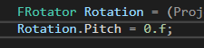

If we later decide to use gravity, we could set this to 25 to 30 degrees up and let gravity bring it down again

Now we set the rotation, requires a quaternion

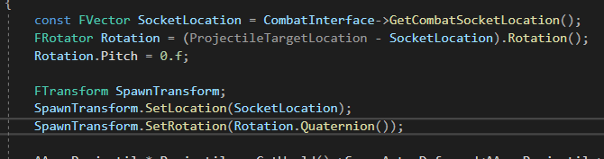

This should send the projectile in the correct direction

In BP set the Location to a local variable

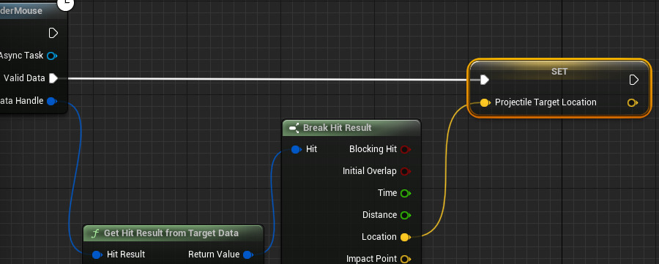

OK, the firebolt now moves in the right direction, but in multiplayer still no firebolt spawning.

This is because the EndAbility is called immediately on the server, and if it’s called immediately it’ll cancel the ability for clients!

If we simply do not end the ability at all the firebolt spawns! …but only once because we are not ending the ability!

Tried plugging End Ability into the Completed Animation, that seems to work OK; more later

Currently the Camera zooms in a great deal when the second player is close by, because the camera is being blocked by the collision settings for Mesh and Collision Capsule. We should change the, but change it in C++

In the BaseCharacter class constructor:

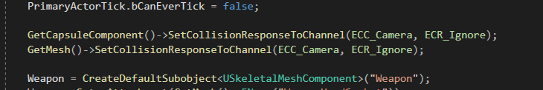

(requires include)

Camera collision fixed!

Additional: Currently if you click an enemy but miss, you run towards it. That’s correct behavior, but for QOL maybe we want to click in the direction of an enemy to launch a firebolt towards it?

Maybe there could be an alt key that allows you to just shoot in the direction with shift?

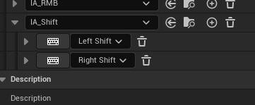

In AuraPlayerController:

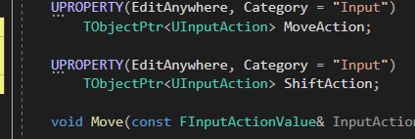



Need a callback function – these can take zero inputs, or an input action value

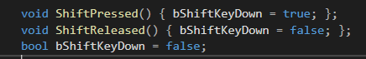

Very simple functions

And the bindings:



Now we always know if Shift is down if we check the Boolean – lets check it if the input is the LMB

In AbilityInputTagHeld: if we are using the LMB the first thing we check is the isTargeting, but we can also check here if ShiftKeyDown

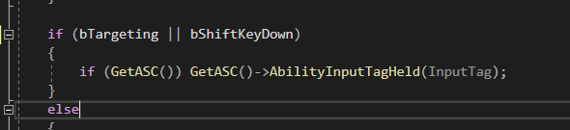

Whether we’re holding ShiftKey, if we release the LMB we should let the AbilitySystemComponent know – in fact we should let it know whether we’re targeting or not, too, because if we click on an enemy we activate the ability if we release after moving the mouse we’re no longer on the enemy the ASC should know we released it

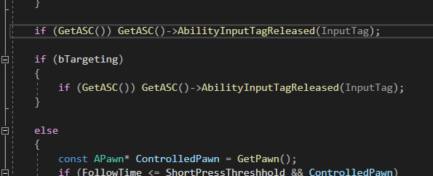

What about movement? If we released the mouse button do we want to check for a short press threshold? Not if we’re targeting or holding the shift

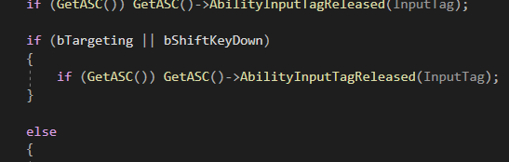

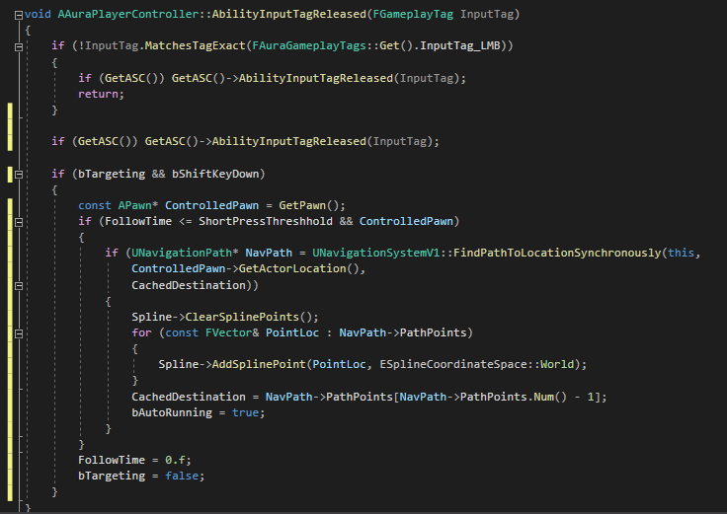

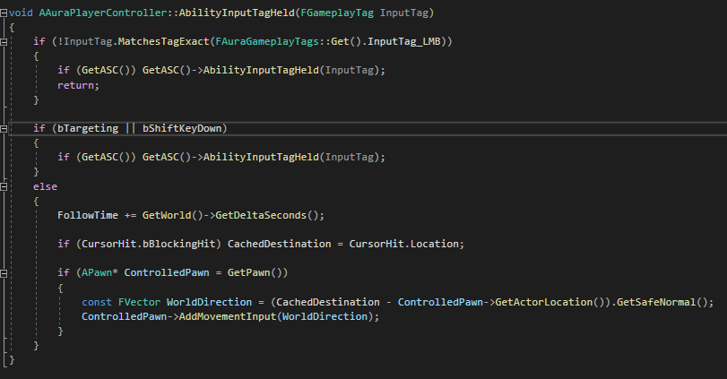

Before testing we need to open the player controller BP

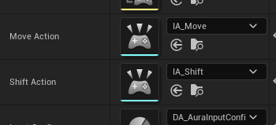

# Motion Warping

Enable Motion Warping Addon and add a new track and Notify state to the AM Cast Firebolt montage

The Notif should be from around the start of the AM to just before casting

Modifiers are Skew Warp

Warp Target Name

Translation OFF

Rotation ON

Rotationtype Facing

In AuraCharacter:

Add component, New event, add input Facing target and

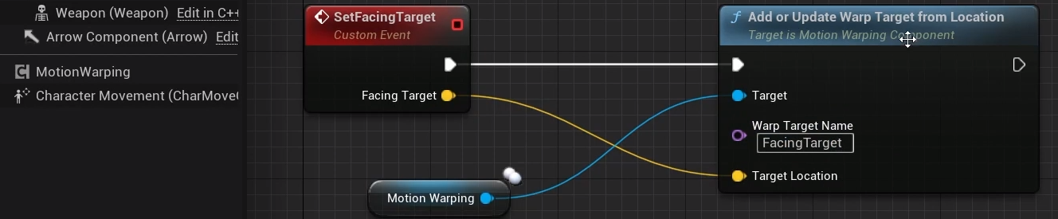

Now while in the Motionwarping window if the Warp Target names match Aura will rotate to that direction

Target is set within the Firebolt ability by casting to BP_AuraCharacter

Nb: makes Firebolt dependent on AuraCharacter!

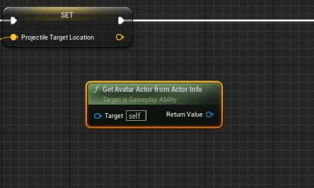

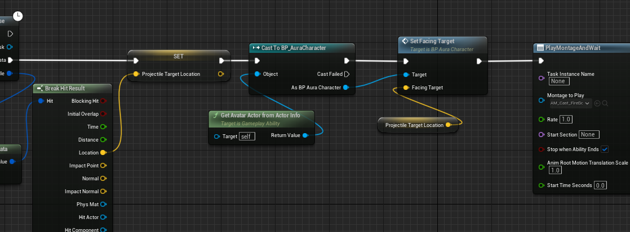

To make more flexible create a function on the combat interface and cast to that

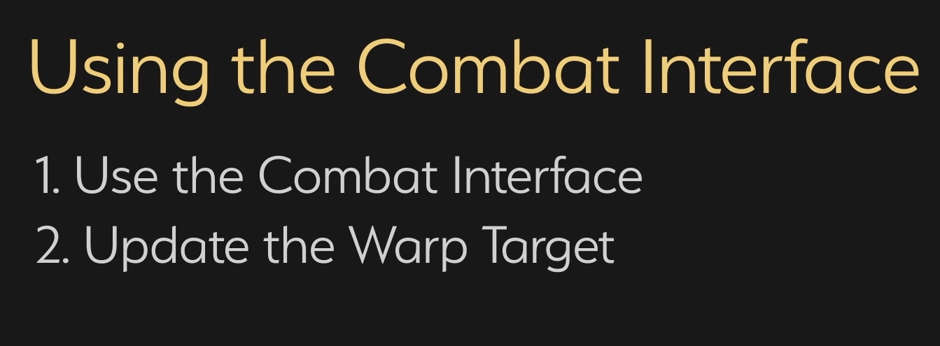

The function needs to take in an FVector and be both BP Implementable and BPCallable

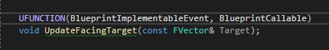

And make the Interface also a BP Type

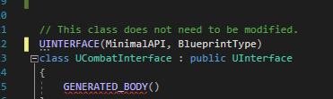

nb BP Implementable Events are not virtual

In AuraCharacter:

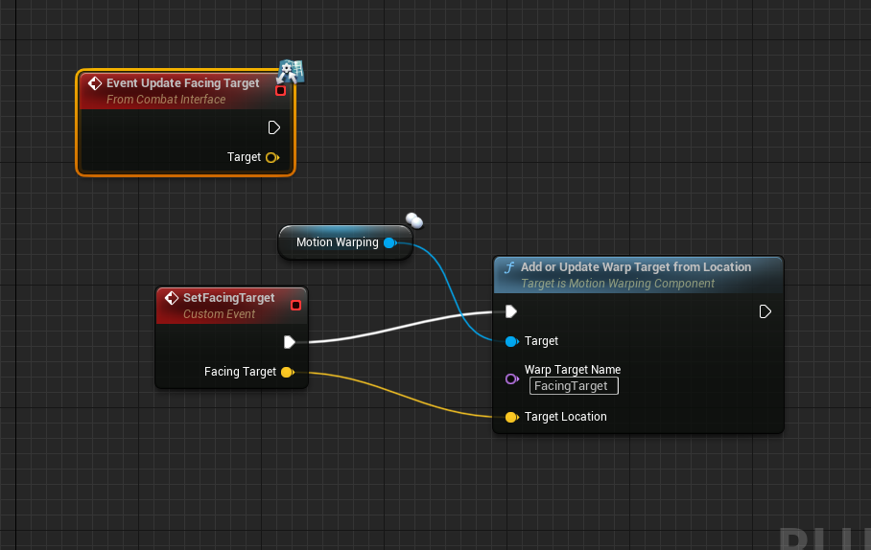

In GA_FireBolt:

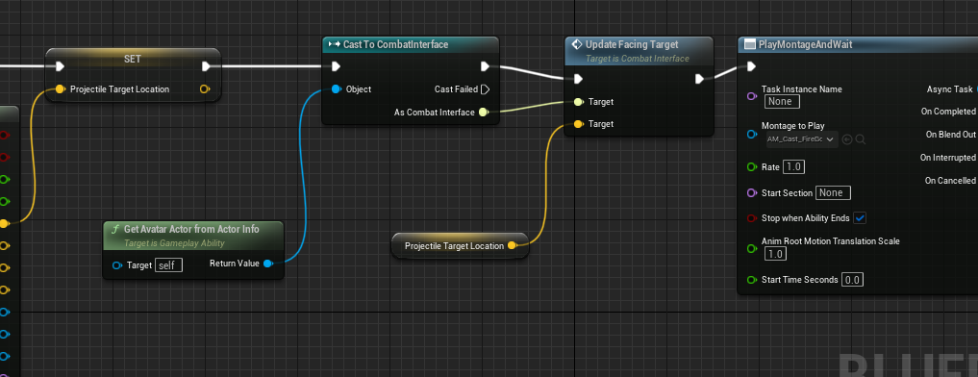

# Projectile Impact

Time to update the projectile hitting stuff!

For now no damage, this is just cosmetics for the moment

To use:

Niagara system effect; sound

So since projectile class is a parent will add some variables

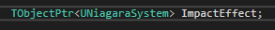 

Since using a Niagara system in code, we should add this to the build script dependancies

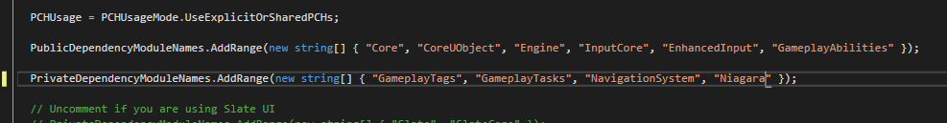

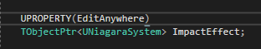 EditAnywhere so we can set in BP

Next, sound:

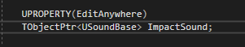

When do we play these effects? When the projectile hits something. Or rather, when it overlaps with something? When it’s destroyed?

But in code, this will be the overlap function

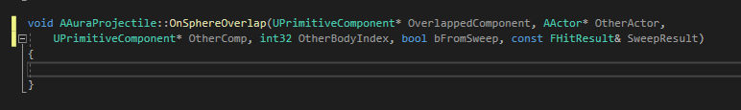

Currently doing nothing

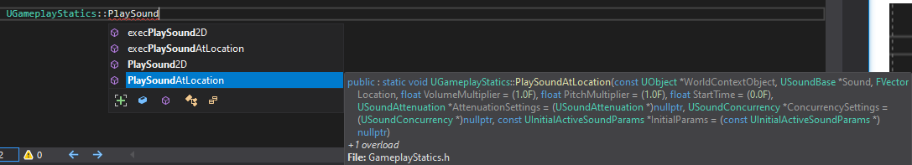

Arguments:

World context object

USoundBase

FVectorLocation

(optional)

The same applies with the Niagara system

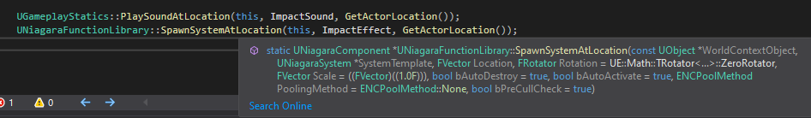

This happens on the server so let’s also destroy the projectile

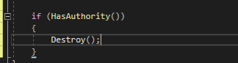

There’s a small chance that the Destroy might replicate down before the effects are played, which would result in the effects not playing locally. To prevent this create a new bool in the header and:

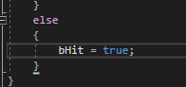

New function:

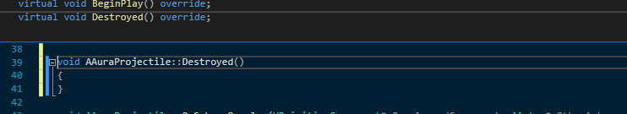

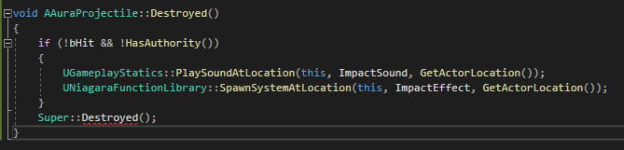

So if destruction happens before the overlap bHit is not true and if we’re not on the server, we’ll play the effects

If Overlap is called before destruction, we replicate the effects

After Destroyed has been called OnSphereOverlap should not be called

In-flight sounds:

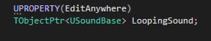

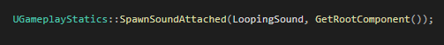

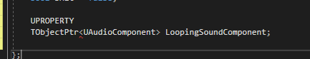

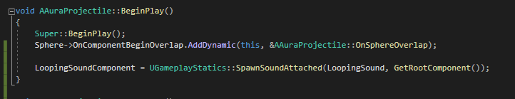

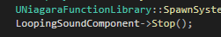

Remember to set the sound in BP!

Additional: if the firebolt does not hit anything, it continues forever, so set a life span

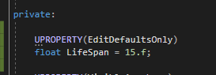 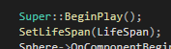

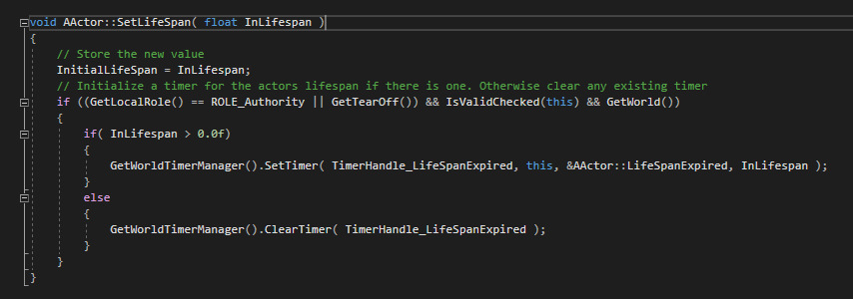

# Projectile Collision Channel

FireBolt should hit pillar, not hit potions and crystals

Pillar should generate overlap events:

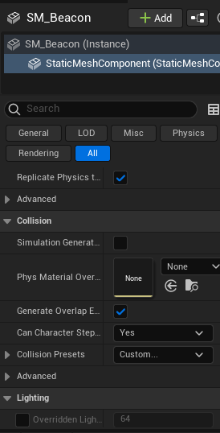

Current settings for the FireBolt:

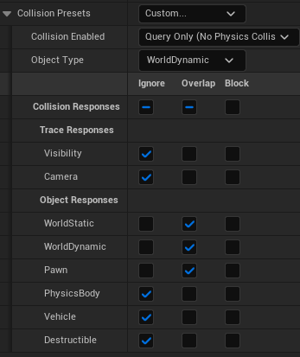

Potion: 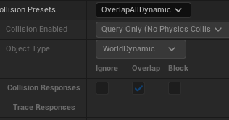

Potion is a worldDynamic, so they’ll collide

We’ll get around this by making a custom object type

In project settings – object channels

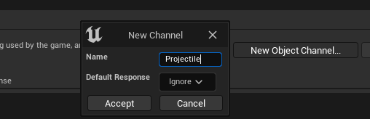

The only things we want to interact with are objects that are worldstatic, world dynamic and pawn; everything else we’ll ignore and manually set the other response as we like

It would be useful to be able to refer to this collision type in C++, so in Aura.h:

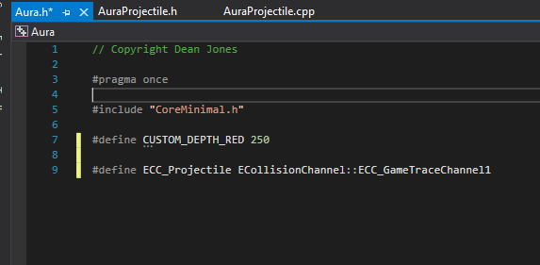

The first custom channel created occupies channel 1 by default

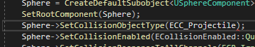 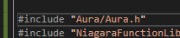

Enemies: 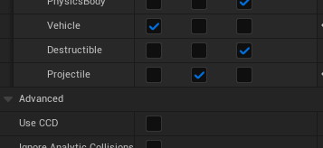

Aura Character Base:

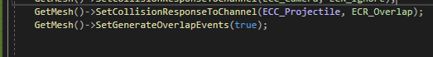

# Projectile Gameplay Effect

Visually the Firebolt looks great, but we want to apply attribute changes by Gameplay Effect

This is going to be a temporary system to get things working – the final damage system will work a little differently

Currently the game has many attributes; these should all affect some aspect of the game, most affecting combat and damage application

For now, basic gameplay affect that will make a change to targets health as a placeholder

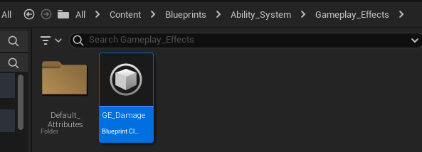 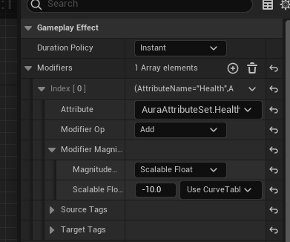

How is the GameplayEffect applied?

The FireBolt needs to carry the GameplayEffect along with it, but it’s better if it carries a lightweight version of it – a GameplayEffectSpecHandle!

In AuraProjectile.h:

The class with have an Effect Spec Handle that will be set when spawning one of these projectiles

Public variable so we can easily set from outside the class

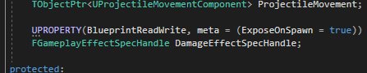 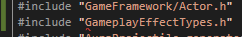

We need to spawn these inside the AuraProjectileSpell:

 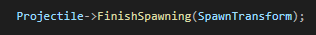

Remember this? 😊

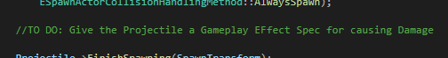

This is where we’re setting it

To have a spec handle we need to use the Ability System Component to call Make Outgoing Spec

And if the projectile spell is going to create a gameplay effect spec it needs to know what gameplay effect class to use for damage

So we’ll need a variable in the .h

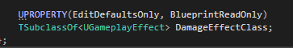 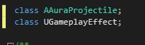

We’ll fwd declare here

Now we need to get the ASC, we can use the AbilitySystemBlueprintLibrary



We use the SourceASC to generate a spec handle (include the ASC header)



If we set this on the ability this will be valid and we can set it on AuraProjectileSpell because we have this variable:



So, in the code right now, we just spawned a projectile called Projectile

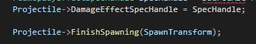

So when we FinishSpawning the Projectile will have had it’s DamageEffectSpecHandle set to the SpecHandle created from the SourceASC

The To-Do is now complete because we have set the Damage Gameplay effect on the Projectile – it will carry the spec handle with it and it’ll then apply that effect to the thing with which it overlaps

So in AuraProjectile in OnOverlap:

Server only, because the effect will change an attribute and the attribute is replicated:

We need the ASC of the actor with which we have overlapped



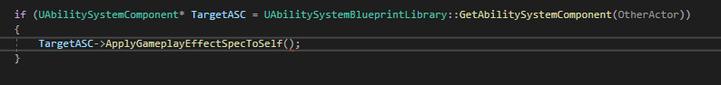

Or we could Get the source of the ability and then apply spec to target



We have the EffectSpec Handle, but we need the Effect Spec

The handle has an internal Data

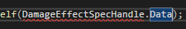

Data is a wrapper isself and has a Get

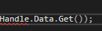

Which returns a pointer, which we have to Dereference



So…now we are applying the Damage Effect to the ASC of the target actor, if the target actor HAS an ASC

To test, we’ll need to set that gameplay effect class on AuraProjectileSpell

How do we know if the effect worked? For now, let’s printstring the enemy health changes from the attributeset class in PostGameplayEffectExecute

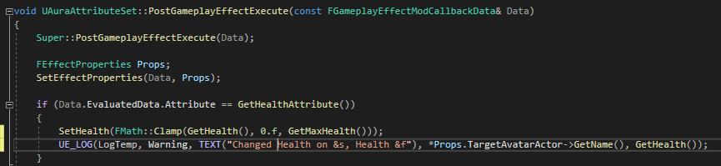

To affect the enemy health, we need to SET the enemy health first!

Aura’s health is set here:

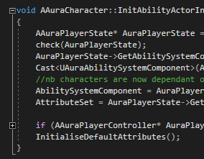

That was defined here:

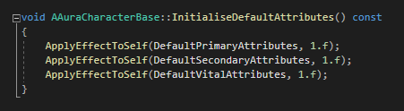

We’re not doing this for the enemy but we could, at least as a placeholder

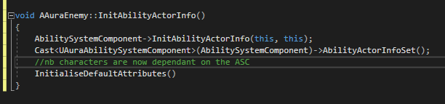

Before playing: AuraProjectileSpell needs Gameplay Effect set in BP and Set enemy attributes in BP

Enemy attributes: we current have no GE Effects for the attributes! As a placeholder we’ll use Aura’s but we’ll make their own soon

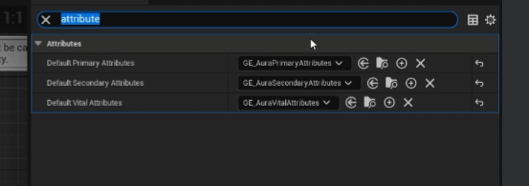

In GA_FireBolt

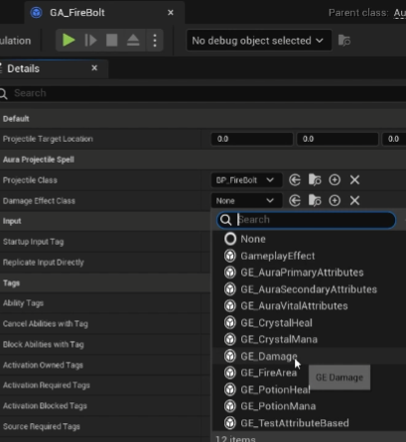

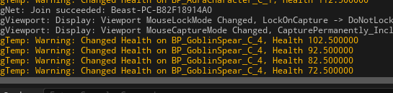

However, bug: Now if you enter the fire effect actor and leave, the effect is no longer removed

Cause: The capsule and mesh both overlap so the effect is applied twice, removed once

# Enemy Health Bar

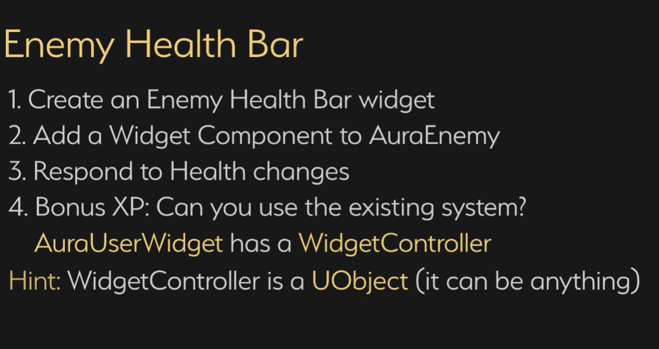

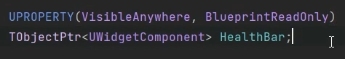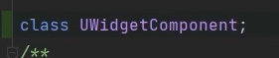

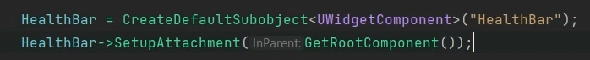

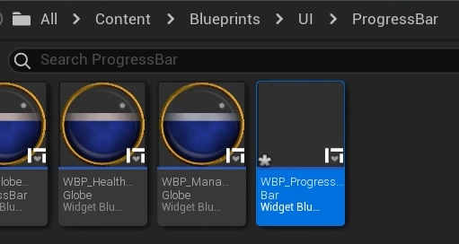

WBP_ProgressBar

SizeBox

Fill desired on screen

W/H Override

isVar

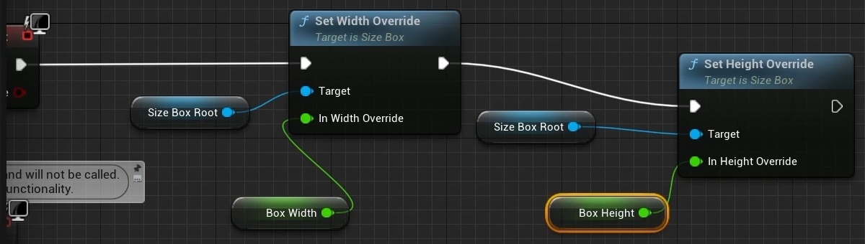

Add Overlay

Add ProgressBar

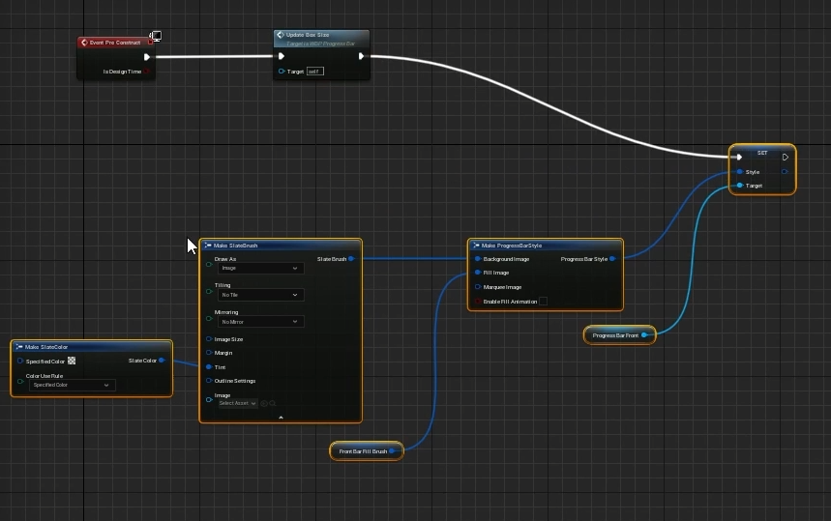

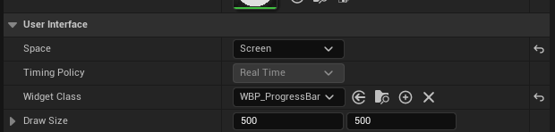

Adding functionality:

If this is to be a health bar it should respond to some sort of delegate broadcast

But it’s also good to keep this generic and allow it to respond to anything and make child classes for health

Any UObject class can act as a controller, so why not the enemy itself?

See OverlayWidgetController.h



Delegate that can broadcast a float

So if we include the OverlayWidgetController header, we can simply use this delegate in the public of AuraEnemy.h

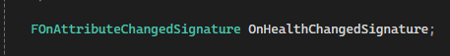

(this kind of dependency isn’t ideal, but it’s not like it’s a huge class to include and if it was a problem we could just put the delegate into it’s own class)

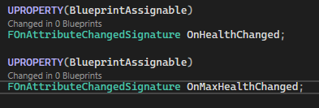

When do we broadcast these delegates to the healthbar?

There are delegates on the ASC we can bind to which are broadcast when attributes change, so maybe bind to those?

When?

First ASC must be initialised, which happens here:

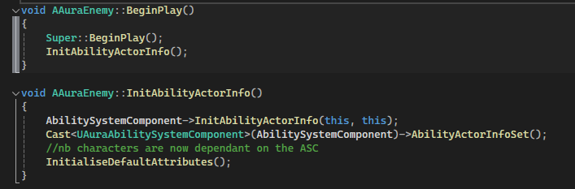

So do it in BeginPlay

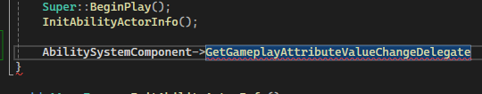

(requires an FGameplayAttribute

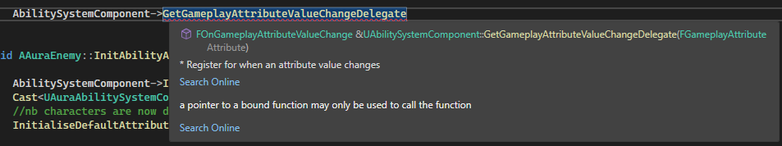

So we need to Get that, so we need to cast to AuraAttributeSet



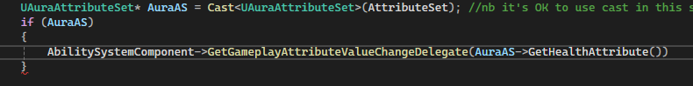

So, after checking the AuraAS pointer is valid, we use the AuraAS pointer to access the GetHealthAttribute delegate



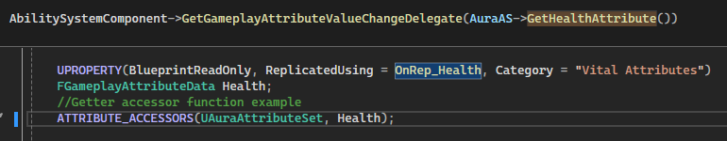

So the delegate has been returned and now we bind to it by Adding a UObject



OR

AddLambda!

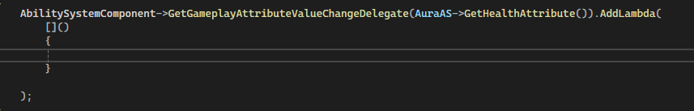

The Lambda will need a specific function signature:





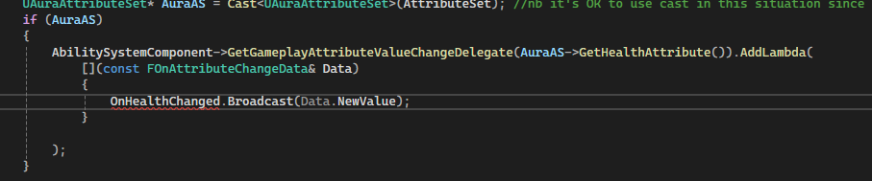

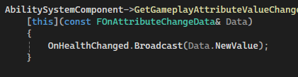

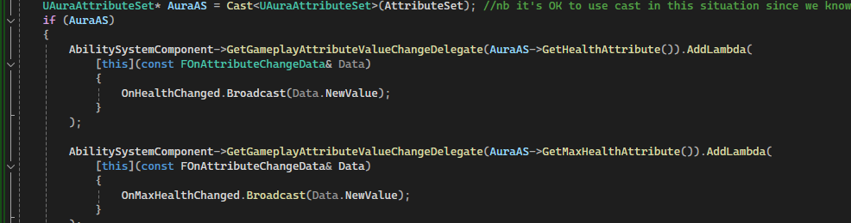

BeginPlay will now take care of binding to the delegates

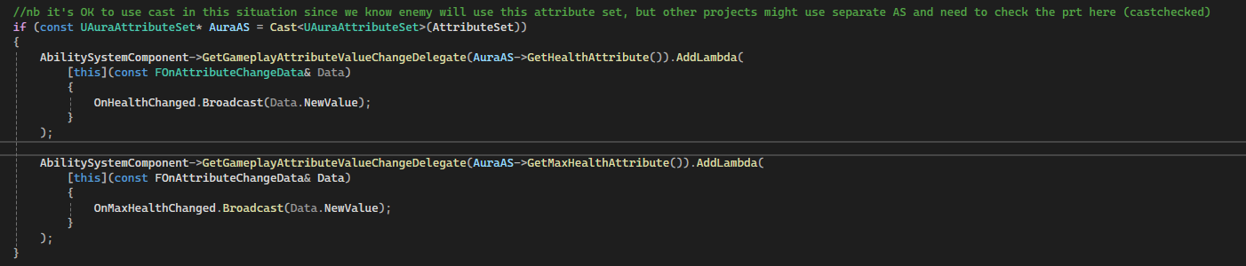

Now that we’re broadcasting delegates for health and max health change is to bind in the progress bar

New child BP: set enemybase to use this new child

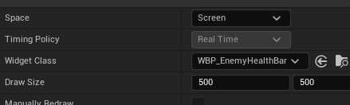

In the new healthbar we need to bind delegates, but also how do we know the Object to bind?

Need a variable but it’s never being set

We’ll set the controller from the enemy itself, as the enemy has access to it. We’ll do that before binding the callbacks

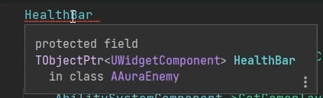

Healthbar has type UWidgetComponent, so we will need to get it’s UserWidgetObject

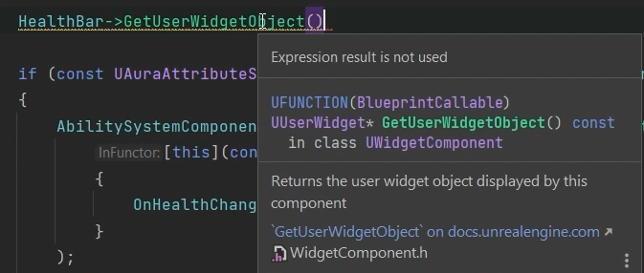

This gets the UserWidget used by the Component itself

We can cast this to a UAuraUserWidget (remember to include) and save locally



This can be put into an If

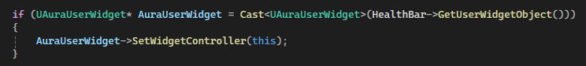

So AuraEnemy are now set to control their healthbars, and the lambdas will broadcast updates to health, but we also need to broadcast and set initial values. We’ll do this after the lamdas once within Beginplay

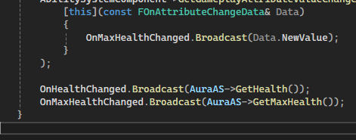

So, first setting progress bar’s widget controller (the progress bar used by this widget component)

The binding the callbacks/Lambdas to get GameplayAttributeValueChangeDelegates on ASC, so those are broadcast in response to attribute changes

Then broadcasting the initial values using that delegate bind

In WBP_EnemyHealthBar:

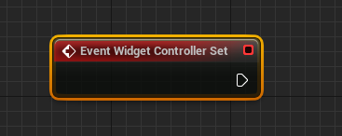

Get WidgetController variable (since it is exposed to BP) and cast

Nb: delegate is on C++ so we could cast there, but the BP is fine

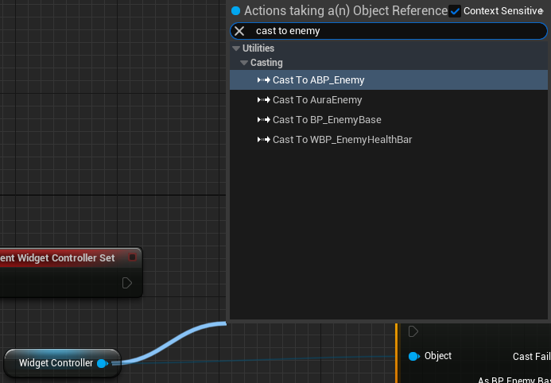

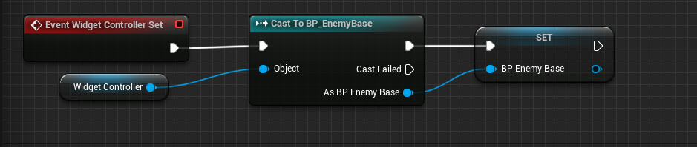

Promote the cast to a variable so we can sequence the boradcasts

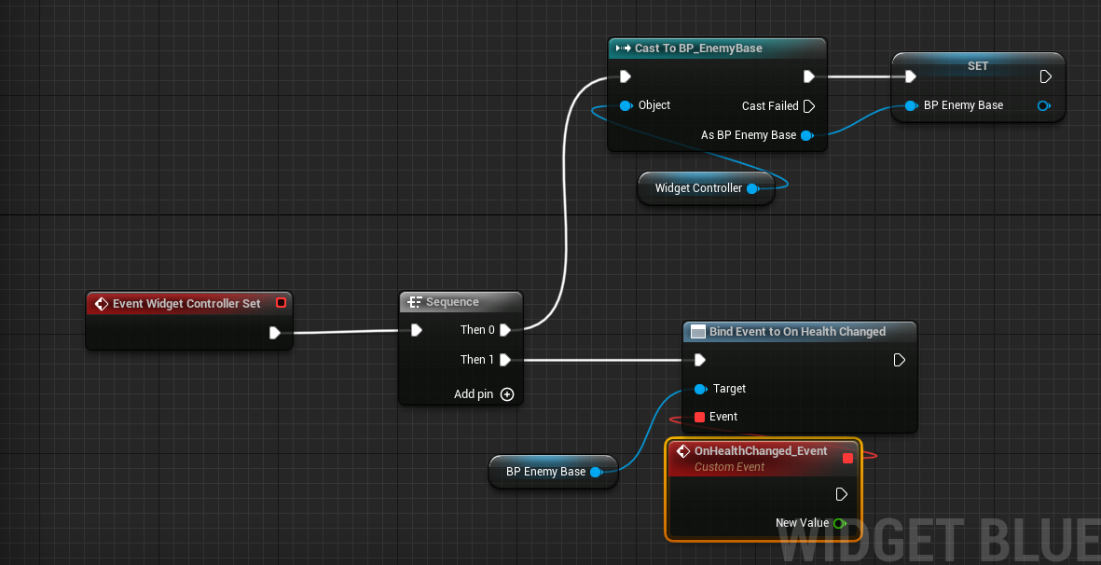

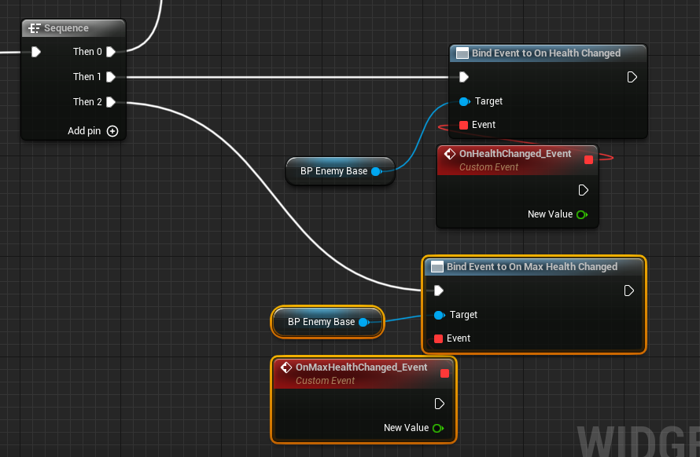

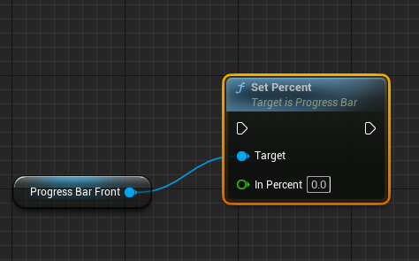

Promote to variables and divide

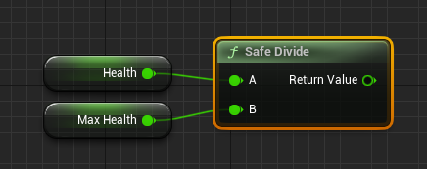

Using SafeDivide to avoid DivideByZero

